NRPA Facility Market Report:

Health and Wellness

**Analysis of:**

**Herndon Community Center**

**814 Ferndale Ave**

**Herndon, VA 20170**

Park and recreation agencies offer a diverse set of offerings and program activities to meet the needs of their communities. But the offerings that work well for one agency, or even one part of an agency’s service area, may not be the best fit elsewhere. As a result, a better understanding of the people most likely served by particular park and recreation facilities—including their greatest needs and desire—is necessary to make decisions on the optimal program and service offerings.

One resource is the **NRPA Facility Market Report: Health and Wellness** for the [Herndon Community Center]. This report offers an array of data that provides your agency with a greater understanding of the residents served by the facility, with a particular focus on their health and wellness related behaviors, conditions, and interests.

Key Findings About the [Herndon Community Center]:

|  |
| --- |
| 130,860 |
| Number of residents living within a ten-minute walk of the facility per Census 2010 |
|  |
| 8.3% |
| Percentage of adult population who use prescription drugs for high cholesterol living within a ten-minute walk of the facility |
|  |
| 25.7% |
| Percentage of adult population living within a ten-minute walk of the facility that exercise at least four hours per week |

**Figure 1: Map of Five, Seven and Ten Minute Walks from the Facility**

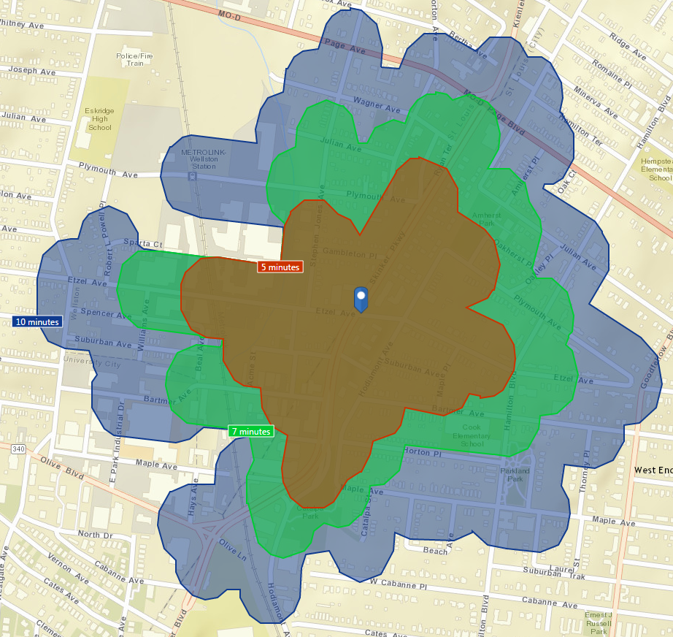

Figure 1 illustrates the physical accessibility, in terms of walking times, of the [Herndon Community Center]. The highlighted areas show the walking times of the facility, broken down into five (brown), seven (green) and ten (blue) minute estimated walk time intervals. Although usage and constituent population will vary by the facility type, the ten-minute walk time area is presented as a *general* guideline on the size of the population most likely to visit the facility. That is, those residing within the area shaded blue may represent the most likely users of common facilities such as recreation and community centers, athletic fields, playgrounds, tennis courts, senior centers and aquatic facilities.

About the Residents Who Live Within a 10 Minute Walk of the Facility

**Figure 2: 2010 Census Data and 2015 & 2020 Forecast Data of People Residing Within a 10 Minute Walk of the Facility**

|  |  |  |  |
| --- | --- | --- | --- |
| Summary | Census 2010 | 2015 Forecast | 2020 Forecast |
| Population | 130,860 | 135,064 | 142,122 |
| Households | 47,693 | 49,316 | 51,922 |
| Families | 32,167 | 33,001 | 34,568 |
| Average Household Size | 2.74 | 2.73 | 2.73 |
| Owner Occupied Homes | 30,036 | 29,493 | 30,900 |
| Renter Occupied Homes | 17,657 | 19,823 | 21,022 |
| Median Age | 34.1 | 35.7 | 36.9 |

|  |  |  |  |  |  |  |
| --- | --- | --- | --- | --- | --- | --- |
| Households by Income |  | | | 2015 Forecast | 2020 Forecast | |
| Median Household Income | |  | $81,973 | | | $90,891 |
| Average Household Income | |  | $107,063 | | | $119,167 |
| Per Capita Income | |  | $41,983 | | | $46,850 |

|  |  |  |  |  |  |  |  |  |  |  |  |  |
| --- | --- | --- | --- | --- | --- | --- | --- | --- | --- | --- | --- | --- |
| Race and Ethnicity | | Census 2010 | |  | | 2016 Forecast | |  | | 2021 Forecast | |  |
|  | **Number** | | **Percent** | | **Number** | | **Percent** | | **Number** | | **Percent** | |
| White Alone | 18,843 | | 75.6% | | 19,119 | | 73.2% | | 19,784 | | 70.4% | |
| Black Alone | 1,787 | | 7.2% | | 1,976 | | 7.6% | | 2,204 | | 7.8% | |
| American Indian Alone | 76 | | 0.3% | | 82 | | 0.3% | | 89 | | 0.3% | |
| Asian Alone | 3,189 | | 12.8% | | 3,723 | | 14.3% | | 4,551 | | 16.2% | |
| Pacific Islander Alone | 4 | | 0.0% | | 5 | | 0.0% | | 6 | | 0.0% | |
| Some Other Race Alone | 480 | | 1.9% | | 560 | | 2.1% | | 680 | | 2.4% | |
| Two or More Races | 561 | | 2.2% | | 660 | | 2.5% | | 803 | | 2.9% | |
| Hispanic Origin (Any Race) | 1,544 | | 6.2% | | 1,758 | | 6.7% | | 2,105 | | 7.5% | |

Figure 2 summarizes Census data of the residents living within a ten-minute walk of the facility, including population, home ownership status, households by income and ethnicity. The 2010 data represents United States Census data, while the 2016 and 2021 figures are projections developed by ESRI. The projections are based on forecasts for births, deaths, international and domestic migration and other factors that influence population shifts. These projections, which naturally are subject to revision, assist your agency in its planning of future programming at the facility over the coming years.  
  
Although most injuries and diseases are colorblind in terms of race, some health concerns disproportionately affect certain ethnic groups due to differences in genetics, diet, lifestyle behaviors, socioeconomic factors, and more. Providing affordable health programs that cater to your community’s racial and ethnic makeup through targeted information, fitness opportunities, and alternatives to unhealthy and unsafe practices, your agency can play a vital role in the overall health of community members.

**Figure 3: Forecasted Age Trends of** **People Residing Within a Ten-Minute Walk of the Facility**

chart.

**Figure 4: Census 2010 Data and Forecasted Age Trends of** **People Residing Within a Ten-Minute Walk of the Facility**

|  |  |  |  |  |  |  |  |  |  |
| --- | --- | --- | --- | --- | --- | --- | --- | --- | --- |
|  | | Census 2010 | | | 2016 Forecast | | | 2021 Forecast | |
| Population by Age | Number | | Percent | Number | | Percent | Number | | Percent |
| 0 - 4 | 10,788 | | 8.2% | 10,023 | | 7.4% | 10,242 | | 7.2% |
| 5 - 9 | 8,851 | | 6.8% | 10,501 | | 7.8% | 9,892 | | 7.0% |
| 10 - 14 | 7,877 | | 6.0% | 8,858 | | 6.6% | 10,206 | | 7.2% |
| 15 - 19 | 6,986 | | 5.3% | 7,123 | | 5.3% | 7,751 | | 5.5% |
| 20 - 24 | 7,391 | | 5.6% | 7,214 | | 5.3% | 6,863 | | 4.8% |
| 25 - 34 | 25,844 | | 19.7% | 22,156 | | 16.4% | 21,227 | | 14.9% |
| 35 - 44 | 22,247 | | 17.0% | 23,444 | | 17.4% | 24,818 | | 17.5% |
| 45 - 54 | 19,043 | | 14.6% | 18,826 | | 13.9% | 19,569 | | 13.8% |
| 55 - 64 | 13,538 | | 10.3% | 15,399 | | 11.4% | 16,299 | | 11.5% |
| 65 - 74 | 5,406 | | 4.1% | 8,029 | | 5.9% | 10,413 | | 7.3% |
| 75 - 84 | 2,085 | | 1.6% | 2,614 | | 1.9% | 3,790 | | 2.7% |
| 85+ | 803 | | 0.6% | 877 | | 0.6% | 1,052 | | 0.7% |

Figures 3 and 4 provide an age distribution of the population living with a ten-minute walk of the facility by age groups, as reported in United States Census and American Community Survey (ACS) data.

Note that the age ranges are not of equal size. The age groups ranging from birth to 24 years old are grouped into five-year increments, ages 25 to 84 are grouped into ten-year increments and individuals 85 years and older are placed into a single age group.

From a recreation programming and planning perspective, the classification of youth and young adults into small age groups aid your agency with programing decisions for children and young adults. Whereas adults within a ten-year age range (e.g., ages 35 to 44) may likely share similar recreation interests, the similarly large size age groups may not make as much sense for children and young adults. For example, recreation interests of five year olds have few similarities of those of 15 year olds. Hence, the five-year age ranges for the younger age groupings provide your agency with more valuable insights about the relative size of the youth population when considering their recreation needs.

Health Related Interests, Activities and Spending Habits

Figures 5 - 7 summarize the weekly exercise habits, at-home gym equipment ownership, and participation in select recreation activities among residents living within a ten-minute walk of the facility. These tables include predictors of exercise activity and recreational activity participation that better inform programming decisions for your facility.

Pay particular attention to the Market Potential Index, or MPI. The MPI represents the relative likelihood of adults living near your facility to engage in a particular activity in comparison to the U.S. average. This measure is indexed to 100, so that an MPI greater than 100 indicates a greater than average likelihood (relative to the whole U.S.) to participate in the activity while an MPI less than 100 suggests a less than average likelihood to engage in the activity.

**Figure 5: Weekly Exercise Habits of People Residing Within a Ten-Minute Walk of the Facility**

|  |  |  |  |
| --- | --- | --- | --- |
|  | Expected Number of Adults | Percent | MPI |
| Spends 7+ hours exercising per week | 26,007 | 25.7% | 113 |
| Spends 4-6 hours exercising per week | 25,705 | 25.4% | 117 |
| Spends 1-3 hours exercising per week | 21,691 | 21.4% | 107 |
| Exercise at home 2+ times per week | 8,747 | 35.0% | 123 |
| Exercise at club 2+ times per week | 4,311 | 17.3% | 133 |

Figure 5 shows the weekly exercise habits of people within a ten-minute walk of your facility. The percentages are the proportion of adults living within a ten-minute walk of the facility that exercise the indicated number of hours or in the indicated specific locations. An MPI value larger than 100 indicates a greater percentage of the adult population living within a ten-minute walk of the facility participates in the indicated field at a higher rate than the U.S. as a whole.

**Figure 6: Ownership Rates of Select Equipment for People Residing Within a Ten-Minute Walk of the Facility**

|  |  |  |  |
| --- | --- | --- | --- |
|  | Expected Number of Adults | Percent | MPI |
| Own elliptical | 1,540 | 6.2% | 156 |
| Own stationary bicycle | 1,762 | 7.1% | 125 |
| Own treadmill | 3,664 | 14.7% | 143 |
| Own weight lifting equipment | 4,500 | 18.0% | 140 |

Figure 6 presents data on the expected number of adults who own certain pieces of home gym equipment among residents living within a ten-minute walk of the facility. Using this data, you can identify specific interests in exercise equipment by residents in your facility’s service area. This information can help create programming that encourages your residents to maintain healthy lifestyles based on activities they already show a personal interest in.

**Figure 7: Participation Rates of Select Recreation Activities of** **People Residing Within a Ten-Minute Walk of the Facility**

|  |  |  |  |  |
| --- | --- | --- | --- | --- |
|  | Expected Number of Adults | Percent | MPI |  |
| Participated in aerobics in last 12 months | 5,894 | 11.8% | 132 | |
| Participated in bicycling (mountain) in last 12 months | 2,494 | 5.0% | 124 | |
| Participated in bicycling (road) in last 12 months | 6,397 | 12.8% | 130 | |
| Participated in hiking in last 12 months | 3,049 | 13.6% | 136 | |
| Participated in jogging/running in last 12 months | 8,935 | 17.8% | 140 | |
| Participated in swimming in last 12 months | 10,070 | 20.1% | 127 | |
| Participated in walking for exercise in last 12 months | 16,428 | 32.8% | 117 | |

Figure 7 summarizes the level of participation in select recreation activities among adult residents living within a ten-minute walk of the facility. Knowing what kind of activities the locals are engaging in can help your agency tailor programs that people will actively want to participate in. This provides another avenue your agency can explore in order to increase in the number of opportunities for physical activity.

**Figure 8: Prescription Drug Usage of** **People Residing Within a Ten-Minute Walk of the Facility**

|  |  |  |  |  |
| --- | --- | --- | --- | --- |
| Used prescription drug for: | Expected Number of Adults | Percent | MPI | |
| Anxiety / Panic | 906 | 4.0% | | 90 | |
| Arthritis / Osteoarthritis | 520 | 2.3% | | 75 | |
| Depression | 948 | 4.2% | | 68 | |
| Diabetes (insulin dependent) | 333 | 1.3% | | 66 | |
| Diabetes (non-insulin dependent) | 877 | 3.5% | | 93 | |
| Heartburn/acid reflux | 1,222 | 4.9% | | 81 | |
| High blood pressure | 3,050 | 12.2% | | 90 | |
| High cholesterol | 2,082 | 8.3% | | 92 | |
| Migraine headache | 807 | 3.2% | | 101 | |

Figure 8 shows the level of prescription drug usage for adult residents that reside within a ten-minute walk of your facility. Understanding the prescription drug usage of residents living near the facility gives your agency a high-level perspective on common health issues. Educating residence on how participating in certain health and fitness programs could be beneficial to specific medical conditions may play a significant role in reducing the rate of chronic illnesses and health conditions like diabetes, hypertension and high cholesterol.

**Figure 9: Doctor Visitation Levels of** **People Residing Within a Ten-Minute Walk of the Facility**

|  |  |  |  |
| --- | --- | --- | --- |
|  | Expected Number of Adults | Percent | MPI |
| Visited doctor in last 12 months | 18,433 | 82.1% | 109 |
| Visited doctor in last 12 months: 6+ times | 7,865 | 35.0% | 119 |

Figure 9 summarizes the occurrence and frequency of nearby residents when it comes to doctor visitation in the last 12 months. These figures may suggest the number of local residents that may have chronic health issues, where parks and recreation can be a part of the solution. At the same time, doctors are trusted advisors to most people. High levels of doctor visits strengthens the case for park and recreation agencies forming and expanding relationships with local medical practitioners, as they can advocate or prescribe their patients to improve their level of activity by visiting their local parks.

**Figure 10: Dietary Control Habits of** **People Residing Within a Ten-Minute Walk of the Facility**

|  |  |  |  |
| --- | --- | --- | --- |
|  | Expected Number of Adults | Percent | MPI |
| Presently controlling diet | 5,718 | 5.6% | 132 |
| Diet control to maintain weight | 129 | 13.5% | 124 |
| Diet control for physical fitness | 132 | 13.9% | 136 |

Figure 10 summarizes the dietary control habits of the population living within a ten-minute walk of the facility. By having insight on the percentage of adults who are actively controlling their diet to maintain weight or for physical fitness, your agency can design specific workshops that focus on the nutritional education and physical activity habits that lead to a healthy lifestyle.

**Figure 11: Dietary Habits of People Residing Within a Ten-Minute Walk of the Facility**

|  |  |  |  |
| --- | --- | --- | --- |
|  | Expected Number of Adults | Percent | MPI |
| Buy foods specifically labeled as fat-free | 132 | 13.9% | 136 |
| Buy foods specifically labeled as low-calorie | 512 | 2.3% | 102 |
| Buy foods specifically labeled as sugar-free | 2,185 | 9.7% | 96 |
| Went to fast food/drive-in restaurant in last 6 months | 48,462 | 90.4% | 100 |
| Went to fast food/drive-in restaurant 9+ times per month | 21,002 | 39.2% | 97 |
| Spent at fast food/drive-in last 6 months: $201+ | 5,965 | 11.1% | 91 |

Figure 11 summarizes the dietary choices made by nearby residents. By applying nutrition standards to the food and beverages you sell and serve to kids and other patrons, your agency can be a model for healthy eating behaviors in the community. Offering evidence-based education materials about nutrition and physical activity to residents will also encourage residents to lead a healthy and active lifestyle.

While all of the habits and activities presented in these tables may not be relevant to your facility, these data provide your agency with guidance on the interests and behaviors of your patrons, as well as some background on health-related activities and dietary choices.

Final Thoughts

While the information within this report is not intended to be indicative of the entire population served by [Herndon Community Center], it gives your agency insights on the potential market for the facility with a particular focus on those living within a ten-minute walk. One note of caution: the analysis provided within this report is meant to be for informational purposes only and does not represent a recommendation by NRPA for the facility’s operations.

**The Premier Membership Advantage**

This report is only one example of the many benefits and resources available to you as a Premier member of NRPA. Your all-inclusive membership gives your agency maximum value and convenience to NRPA’s exceptional benefits and resources including:

* Up to 30% discount on NRPA products and services.
* A bulk purchasing discount on conference registration, certification, online learning and more.
* 10 free Premier-exclusive webinars.
* Access to approximately $2.4 million in grant opportunities annually.
* Member discounts on insurance, background screenings, software and more.

For a full list of your membership benefits, please visit [www.nrpa.org/Member-Benefits](http://www.nrpa.org/Member-Benefits)

**Sponsored by Playworld**

Playworld creates innovative commercial playground equipment that brings the joy of play to people of every age. They don’t just make playground equipment. They are in the kid–empowering, confidence–building, friendship–making, health–promoting, community-strengthening business. Playworld does this because, quite simply, they believe that The World Needs Play®.  
*© COPYRIGHT 2016 National Recreation and Park Association. Portions of this document includes intellectual property of Esri and its licensors and are used herein under license. © COPYRIGHT 2016 Esri and its licensors.*