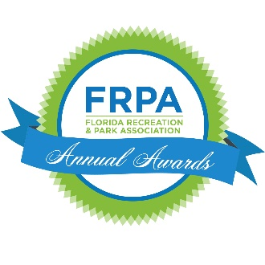
Nomination Form

The Florida Recreation and Park Association's Parks Professional Award recognizes the continuous dedication of a park employee who has demonstrated outstanding service to the field of parks and recreation.
Criteria for selection:
- The individual must have been employed more than five years, in a full-time position in the parks, natural resources management, or environmental protection profession.
- Performed special and/or unusual service to the field of parks and recreation.
- Maintains a professional image in their community, both on and off the job.
- FRPA membership and involvement is not required but is considered in the judging criteria.

Name of Nominee
Nominee Address
Nominee Email Address
Nominee Job Title
City/State/Zip
FRPA Member?
Nominator Name
Nominator Phone
Nominator Email Address
Nominator Relationship to Nominee
Name of Agency/Organization
Does this nominee represent an underrepresented population?
Continued on Next Page

This award will be judged with a maximum of 91 points available. A minimum score of 71 is required to be considered an award finalist. In order to maximize the number of points earned it is imperative that the nominator thoroughly completes all elements of this application. Your application must include the following to be considered:

NARRATIVE (provide as an attachment)
40 points maximum available | max 3 pages; 1.5 spaced; 12 pt font

- Describe how the individual shows distinctive leadership as a support staff, crew leader, park supervisor, park ranger, or other parks professional.
- Describe how the individual’s dedication to service has advanced the mission or vision of their agency.
- Describe any special or unusual service provided to the community or the profession.

SPEAKING
10 points maximum available
Nominees may be awarded up to 10 points if they have spoken at conferences or local educational offerings focusing on parks or recreation in the last two years.

Topic of Presentation | Event Presented at | Date

PARTICIPATION
12 points maximum available
Nominees may be awarded up to 12 points if they have participated in an FRPA sponsored training in the last two years.

Event | Date Attended

TWO LETTERS OF SUPPORT  10 points maximum available  - Letter of support from the Agency Director  - Letter of support from a supervisor, colleague or community member | OTHER ATTACHMENTS  15 points maximum available  Copies of pictures, certifications, trainings, newspaper, or other information supporting the nomination. | FRPA MEMBERSHIP  4 points maximum available  While not required, individuals who are current FRPA members will be awarded 4 points.

Your application and submission will be reviewed by a panel. The panel will score your application and submission based not only on the completeness of your application, but also for how creative and thorough you are in your submission and narrative descriptions. This application is not just a checklist. It is an opportunity for you to demonstrate how this person excels, and why the person is deserving of this recognition.

SUBMISSION FORMAT: All Award Nominations must be submitted electronically. Please follow the steps below to make your submission:
- Complete the nomination form (page one) by typing directly onto this document. This must be included in your final submission.
- Type your responses to the Narrative sections.
- Your submission should be in this order:
  - Nomination Form
  - Narrative
  - Speaking and Participation Record (page 2)
  - Letters of Support
  - Other Attachments
  - Supplementary Material
- If you need direction about creating a pdf from multiple documents, click here.

All applications MUST BE TYPED. NO HANDWRITTEN SUBMISSIONS WILL BE ACCEPTED.

Complete the Nomination Form in its entirety and send as ONE pdf file to eleanor@frpa.org.
To be eligible, nominations must be received via email no later than April 30, 2023. You will receive a confirmation email that the nomination has been received.

