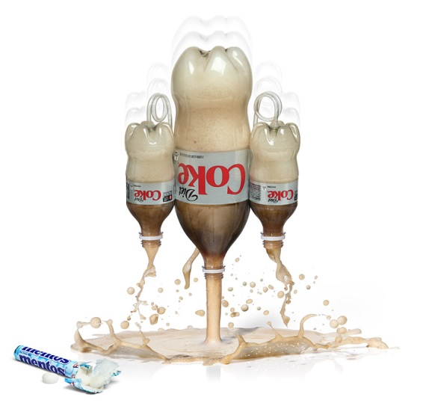
Diet Coke and Mentos

Mentos Geyser Experiment
Drop Mentos into a bottle of soda and run away from the 20 foot geyser
It’s been called the “vinegar and baking soda” reaction for a new generation. While science teachers have been dropping candies and mints into 2-liter bottles of soda for years in an effort to release all of the dissolved carbon dioxide, the Mentos and Diet Coke reaction became world famous in 2005. Fueled by hundreds of blogs and popular online sharing sites like youtube, this once obscure reaction became an Internet sensation, and the enthusiasm for dropping Mentos into soda continues to grow. Once you get past the initial gee-whiz factor, there’s some amazing science behind a carbonated beverage and a chewy mint.

Experiment Materials
- A roll or box of Mentos chewy mints (stick with the standard mint flavor for now)
- 2-liter bottle of diet soda (either diet or regular soda will work for this experiment, but diet soda is not sticky when you’re cleaning it up, and it will usually create a bigger blast)
- Sheet of paper to roll into a tube
- Steve Spangler’s Geyser Tube toy (optional . . . but highly recommended!)

Experiment
This activity is probably best done outside in the middle of an abandoned field or on a huge lawn.
Carefully open the bottle of diet soda. Again, the choice of diet over regular soda is purely a preference based on the fact that erupting regular soda becomes a sticky mess to clean up because it contains sugar. Diet soda uses artificial sweeteners instead of sugar, and consequently, it’s not sticky. Later on in the experiment, you’ll be invited to compare the geyser power of diet versus regular soda, but for now we’ll start with a 2-liter bottle of diet soda.

Position the bottle on the ground so that it will not tip over.

Let’s start with seven Mentos for our first attempt. The goal is to drop all seven Mentos into the bottle of soda at the same time (which is trickier than you might think). One method for doing this is to roll a piece of paper into a tube just big enough to hold the loose Mentos. Other methods include using a large plastic test tube to hold the Mentos or using my Geyser Tube toy invention, which was created to solve this very problem. Assuming that you’re using the paper tube method, you’ll want to load the seven Mentos into the tube, cover the bottom of the tube with your finger, and position the tube directly over the mouth of the bottle. When you pull your finger out of the way, all seven Mentos should fall into the bottle at the same time.
Enough waiting . . . this anticipation is killing me. 3-2-1 drop the Mentos!

This final step is very important . . . run away! But don’t forget to look back at the amazing eruption of soda.

If spectators were watching your exploits, someone is bound to yell out, “Do it again!” and that’s exactly what you’re going to do.

How Does It Work
Why do Mentos turn ordinary bottles of diet soda into geysers of fun? The answer is a little more complicated than you might think. Let’s start with the soda . . .
Soda pop is made of sugar or artificial sweetener, flavoring, water, and preservatives. The thing that makes soda bubbly is invisible carbon dioxide (CO₂), which is pumped into bottles at the bottling factory using lots of pressure. If you shake a bottle or can of soda, some of the gas comes out of the solution and the bubbles cling to the inside walls of the container (thanks to tiny pits and imperfections on the inside surface of the bottle called nucleation sites). When you open the container, the bubbles quickly rise to the top pushing the liquid out of the way. In other words, the liquid sprays everywhere.
Is there another way for the CO₂ to escape? Try this. Drop an object like a raisin or a piece of uncooked pasta into a glass of soda and notice how bubbles immediately form on the surface of the object. These are CO₂ bubbles leaving the soda and attaching themselves to the object. For example, adding salt to soda causes it to foam up because thousands of little bubbles form on the surface of each grain of salt. This bubbling process is called nucleation, and the places where the bubbles form, whether on the sides of the can, on an object, or around a tiny grain of salt, are the nucleation sites.
Why are Mentos so Special?
The reason why Mentos work so well is twofold—tiny pits on the surface of the mint, and the weight of the Mentos itself. Each Mentos mint has thousands of tiny pits all over the surface. These tiny pits act as nucleation sites—perfect places for CO₂ bubbles to form. As soon as the Mentos hit the soda, bubbles form all over the surfaces of the candies and then quickly rise to the surface of the liquid. Couple this with the fact that the Mentos candies are heavy and sink to the bottom of the bottle and you’ve got a double whammy. The gas released by the Mentos literally pushes all of the liquid up and out of the bottle in an incredible soda blast.

