Soda Bottle Terrarium

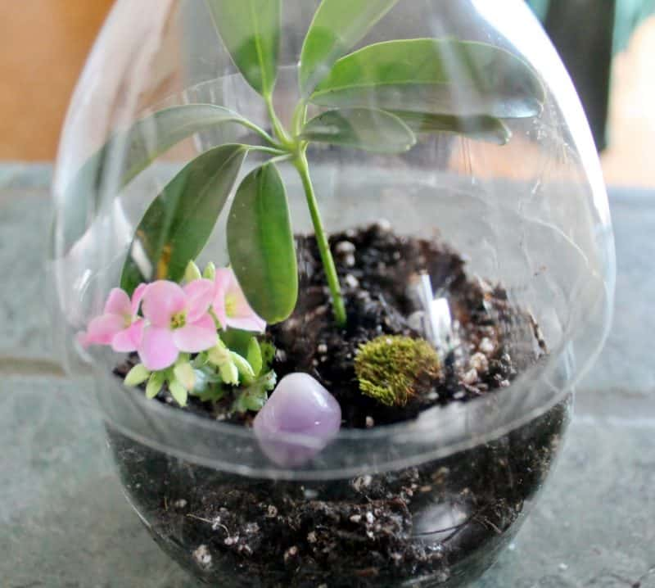
Supplies:

- small pebbles,
- charcoal,
- potting soil,
- a few terrarium happy plants, like small succulents
- a coke bottle
- an exacto knife
- scissors

Directions:
- In order to make this project, you must use a coke (or diet coke) bottle because it has just the right shape. It comes inward near the bottom, which allows the top to sit over it pretty securely.
- Cut out the middle part so that the bottom measures 3.5″ and the top measures 5″. I used an exacto knife to make the first cut then small, sharp scissors to finish cutting. I didn’t have enough control with the exacto knife to make a straight edge.
- Gather together your supplies: small pebbles, charcoal, and potting soil. Start with the pebbles, followed by the charcoal, and then the potting soil.
- I found it difficult to locate terrarium plants in the Northeast during the dead of winter, so I kind of had to scrounge around. The two in the back are tropical plants I purchased at Aldi’s for $2.00 each–an Umbrella plant (L) and a Janet Craig (R). The one in front is a mini plant from Trader Joe’s. I’m not sure what it is, but I’m don’t think it’s tropical, so it may not fair well in my terrarium. But it’ll sure look purty for a while.
- I took the Umbrella plant out of its pot and split it until I found a small piece with some root attached that would fit nicely in my little terrarium.
- I did the same with the tiny pink plant–broke away a piece. Then I made little impressions in the dirt and set the plants into the potting soil layer, tamping them down to secure them. The Janet Craig ended up being too big for this container, so I set it aside for another project.
- I added a pretty tumbled stone and a bit of moss and called it a day. Since this is an airtight terrarium, it should pretty much take care of itself. If something begins to mold, I’ll take it out right away. Same with dead blossoms. If the dome fills with condensation, I’ll take the lid off to let it dry out a bit.

