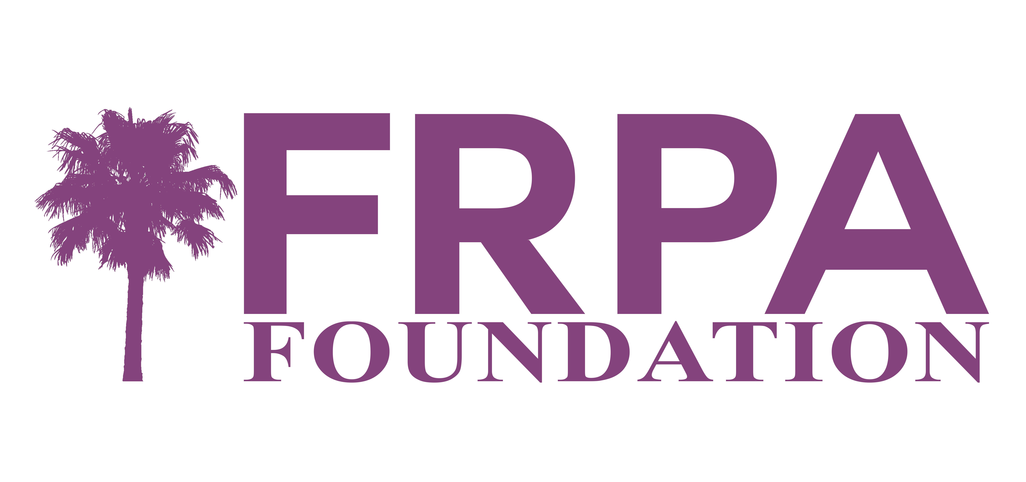
Proctor Stavres Scholarship Criteria

The intent of the Proctor Stavres Scholarship is to provide financial assistance to persons pursuing higher education in the fields of Parks and Recreation, Therapeutic Recreation, Leisure Services Administration, Natural Resource Management, Special Event Management or other field deemed relevant to the Parks, Recreation and Leisure Profession. Applicants may be enrolled full or part time in a graduate or undergraduate degree program. Applicants must be degree seeking or completing a recognized certificate program.

The Proctor Stavres Scholarship is funded through the Florida Recreation and Park Association Foundation.

Criteria for the Scholarship include:
- Scholarship is only to be used for students who are from the State of Florida and pursuing a Bachelor’s or Master’s degree in the areas above. Preference is given to students enrolled in Florida colleges/universities.
- The scholarship can be applied towards the cost associated with Certificate programs, however these programs must be central to parks and recreation only.

Applicants must be able to document/demonstrate the following criteria:
- Current enrollment in a college/university verified through a copy of an unofficial transcript or other documentation from the college/university.
- Professional work experience (full time or part time) or volunteer service with a parks, recreation or leisure provider, verified through a letter from the employer or volunteer coordinator.
- Community service outside of or separate from their professional capacity in parks, recreation and leisure. This can include service to civic organizations, faith based entities, school or educational institutions, social service providers, etc. Membership with an organization is not sufficient; the applicant must be able to document or demonstrate active involvement in service related initiatives.
- Member of the Florida Recreation and Park Association at the time of application and commitment to maintain membership for two years following award.

In addition to meeting the above criteria, the applicant must submit an essay of no less than 750 words and no more than 1000 words addressing how you believe the parks and recreation profession contributes to the health of communities; has an economic impact on communities or contributes to the economic development of a community; establishes environmental sustainability in communities; or builds community. Include how parks and recreation has benefitted you personally.

There are two submission cycles.
SPRING FALL
Applications due by 5pm on March 1st. Applications due by 5pm on September 1st.
Notification of award by April 1st. Notification of award by October 1st.

The available scholarship dollars will be determined once the number of applicants is known.

A Scholarship Committee is comprised of two current Trustees of the FRPA Foundation, two current members of the FRPA Board of Directors, and a park and recreation professional not on either Board, to be selected by Charlotte P. and T. Michael Stavres will review the applications and select a recipient.
Proctor Stavres Scholarship Application

Name: ________________________________________________________________________
Street Address: ________________________________________________________________

City/State/Zip: _________________________________________________________________

Phone w/Area Code: ________________________________________________
Email Address: _____________________________________________________

Permanent Address if different from above: _________________________________________
City/State/Zip: ___________________________________________________________

Are you currently employed in the parks and recreation field? ___________________________
If yes, what agency? _____________________________________________________________

University/College Currently Attending: _____________________________________________

Expected Graduation Date: _______________________________________________________

Declared Major: ________________________________________________________________

Applying for Scholarship to Fund:
_____ Degree _____ Graduate _____ Undergraduate
_____ Certificate Program in ______________________________

Summarize Professional Work Experience (please note whether full or part time): Attach a letter from your supervisor documenting work experience.

Summarize volunteer service to a parks, recreation or leisure provider. Attach a letter from your volunteer coordinator documenting volunteer service.

Summarize Community Service (Service can include service to civic organizations, faith based entities, school or educational institutions, social service providers, etc. Membership with an organization is not sufficient; the applicant must be able to document or demonstrate active involvement in service related initiatives.) Attach a letter from your volunteer coordinator documenting volunteer service.

Provide a listing of other scholarship funds that you have been awarded that will be applied to the coming year’s coursework.

Please respond with less than 750 words and no more than 1500 words addressing how you believe the parks and recreation profession contributes to the health of communities; has an economic impact on communities or contributes to the economic development of a community; establishes environmental sustainability in communities; or builds community. Include how parks and recreation has benefitted you personally. (This is your opportunity to demonstrate your passion for and belief in the field of study you have chosen. This should not be a summary of research and articles that you can find. Let us hear your connection to parks and recreation, with minimal citing of research and/or quotes.)

Submit Your Complete Application, a Resume, and a Transcript electronically to: eleanor@frpa.org.
These can be three separate files but the Application should remain a word document that you type directly on.

