.

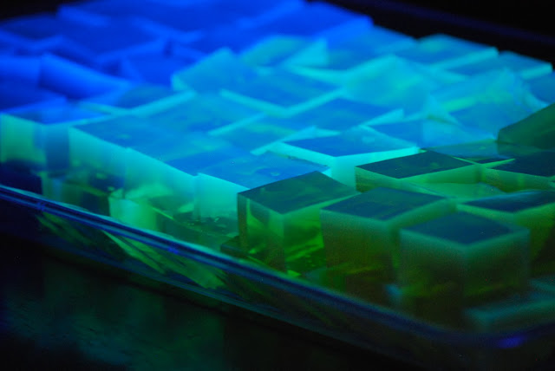
Glow in the Dark JELL-O

Glow in the dark JELL-O is not only a fun science project, but a super fun camp treat. Pick up a black light or black light bulb at your local Home Depot shop to show off it’s glow!

Ingredients
- Black Light
- tonic water
- 1 package of GREEN JELL-O
- Pan or ice cube trays
- Fruit , Whipped Cream and Sprinkles for topping (optional)
Instructions
- Follow direction on box but replace TONIC WATER for WATER
- Pour JELL-O packet into a large bowl.
- Have a grown-up help you add your hot tonic water.
- Stir for two minutes with a wire whisk.
- Slowly whisk while adding the tonic water. The mixture will be very bubbly. Give it a couple of minutes to rest.
- Pour it into tray
- Place in the refrigerator for two to three hours to set.
- Top with whipped cream and sprinkles.
- Place under a black light and watch it glow.

Why was the broom late ?
It over swept !

Do you know the time?
No, we haven’t met yet!

What Kind of hair do oceans ?
Wavy!

What runs but never walks ?
Water

How do you make milk shake ?
Give it a good scare !

Whats red and flies and wobbles at the same time?
A jelly copter !

