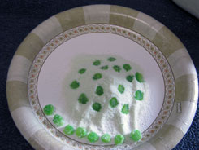
. Gummy Candies
http://sciencemadefunkids.net
Supplies:
- Paper Plate
- Cup of Water
- Pipette or Eye Dropper
- Gelatin Powder

Instructions:
- Sprinkle a small mound of gelatin powder onto the middle of the paper plate
- Take the pipette and make one drop right onto the pile; then move the pipette over to a different spot and make another drop. Repeat, making a total of 5 drops.
- Count to 20; then take the tip of the pipette and very carefully push the gummy candies off the pile and over to the side of the plate.
- Repeat steps 1-3, Eat & Enjoy!
The Science behind it:
Water can be found in each of the millions of cells within the human body; therefore, water makes up approximately 3/4 or 75% of our bodies. When water reacts with proteins found in our bodies, these proteins become stretchy or even gummy. The gelatin, in this case, represents the proteins found in our body & when it reacts with water it becomes gummy...and yummy!

