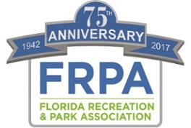

Best Practices

The Florida Recreation and Park Association adopted a comprehensive Strategic Plan in 2015. That Plan is based on four foundational pillars – Health, Community Building, Environmental Sustainability and Resiliency, and Economic Impact/Development.

The Association is in search of Best Practices in each of these four areas, which can serve as a resource for parks and recreation professionals. We realize that “Best Practice” can be broadly applied and the meaning varies depending on the environment and industry one works within.

For the purposes of the FRPA Strategic Plan, the Association’s Board of Directors has adopted and will apply the following definition:

FRPA Strategic Best Practices – Methods, professional guidance, benchmarks and technical expertise centered around a FRPA strategic pillar (Health, Environment, Community Building, Economic Impact) that are evidence-based or proven through experience to support positive results and may be replicated or utilized by other parks and recreation agencies toward achieving a similar desired outcome.

“Evidence-based or proven through experience” indicates that the best practice has had some research, or long term monitoring conducted to show that the practice is having a positive outcome when applied. For example: When applying the best practice of mowing and over-seeding in this manner, for a period of one year, we have been able to extend the life of our turf by 6 months thus reducing expenses $X; OR When integrating physical activity and nutrition education in our after school programming, we partnered with the University of XYZ to measure increased health of participants, and have shown a 24% reduction in BMI of participants.

We realize that there may be a plethora of “success stories” that are not evidence based, but have produced positive results for an agency, and may also have value as a shared resource.

Submissions will be evaluated by the Best Practice Workgroup to determine if the submission meets the criteria of “Best Practice” as we have defined, or if it should be catalogued as a “success story”.

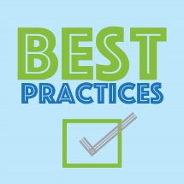

Best Practice Submission

Agency: ______________Orange County Parks and Recreation Division_______________________________

Contact Name: _________Alicia Baxter________________________________________________________

Contact Email: _________Alicia.Baxter@ocfl.net__________________________________________________

Contact Phone with Area Code: __407-836-6205_________________________________________________

Area of Best Practice: ENVIRONMENTAL PILLAR: Managing Community Trees
ex: selection/design per area/inventory/selection/maintenance/public relations/etc.

Summary of Best Practice: (include description of the practice, reason for adopting/implementing best practice, measurement of effectiveness of the practice, what is your evidence that the practice is working, etc.)
Orange County Parks and Recreation has adopted a best practice of selecting Florida Friendly species in overall design (e.g. Right plant=Right place). Effectiveness is measured per planting project, normally via overall mortality numbers, after a designated period of time has passed.

After a series of incidents in which same-species old growth trees died in large numbers, Orange County has sought to plant diverse species over a period of time, e.g. no monocultures.

Additionally, mulch used in tree rings is required to be either melaleuca or pine, only (no cypress mulch permitted due to environmental impacts to old growth forests).

On a larger scale, Parks and Recreation is involved with the County’s urban forest analysis and a grant opportunity that seeks to link urban tree canopy to stormwater mitigation.

For our tree contract (for tree removal/pruning, etc. above and beyond what internal staff can handle) we have the following requirements:
- The Contractor shall guard against tree damage. Climbing irons, spurs, and spikes are permitted only during removal. Any tree damage caused by the Contractor shall be repaired at no cost and to the satisfaction of the Project Manager.
- The Contractor shall grind all stumps six (6) to eight (8) inches below the soil surface. The stump hole shall be filled, tamped, and mounded at three (3) includes high to allow for decomposition of root mass.
- The Contractor shall comply with the most current revision of A.N.S.I. Z-133.1 Safety Standards for Tree Care Operations, Pruning, Trimming, Repairing, Maintaining, Removing Trees, and for Cutting Brush.
- The Contract shall conform to the latest version of standards of the National Arborist Association, A.N.S.I. A3000. Pruning shall be performed in accordance with Class I (Fine Pruning specifications).
- The Contractor shall have a Certified Arborist on staff.
- For tree plantings, the following shall be considered (see image, next page)

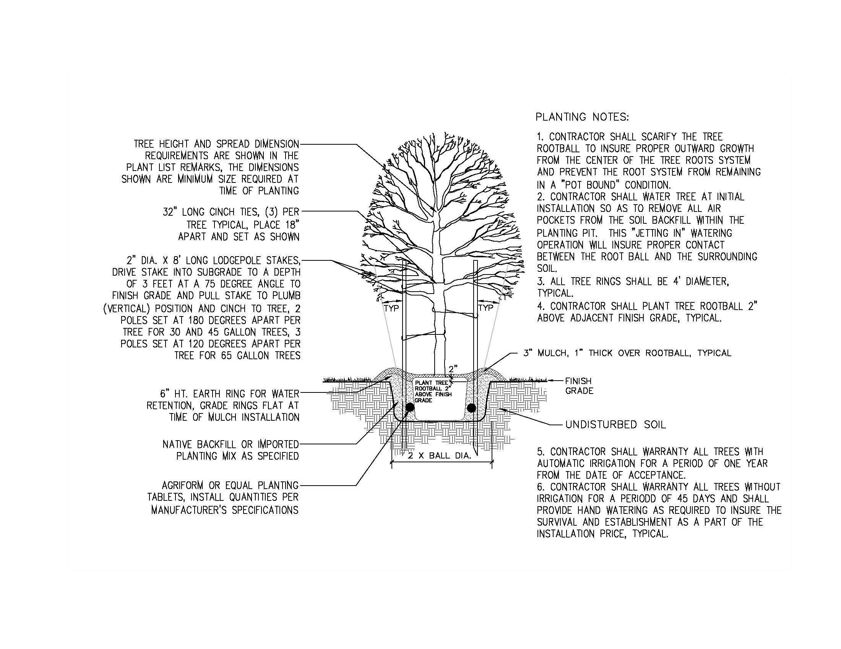

Frequency Best Practice is Applied: (daily, weekly, monthly, quarterly, bi-annually, annually)
Ongoing per project, no specific timeframe.

Who Performs the Best Practice Function within your Agency: (contracted, in-house parks staff, in-house recreation staff, citizens, etc.)
In house Landscape Architects (LA) provide design/selection or, for large scale construction projects, LAs oversee contracted design and planting. For small projects, individual park site supervisors have been tasked with selecting/planting native tree species.

Positive Outcome of the Best Practice (please summarize the evidence based benefit that has been derived by the agency from the best practice):
Outcomes:
- Less water, fertilizer, and pesticides used.
- Attractive to native wildlife
- Healthier trees, long-term

Awards/Recognitions/Designations Received as a Result of the Best Practice (please share any awards or designations received, or publications that have featured this best practice):
N/A

Grants or Funding Received (if any):
Orange County received a tree planting grant in 2014

What other Best Practices would you suggest we collect?

Submit this Form electronically to charla@frpa.org
Type directly onto this document, and submit as a Word Document. Please DO NOT pdf the form.

