Dragon Fire Puppet

Supplies:
- Toilet Paper Roll
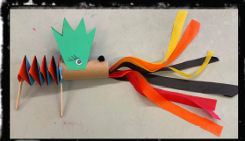
- Cardstock Paper
- Tissue Paper (~1” strips)
- Scissors
- Liquid Glue
- Googly Eyes
- Popsicle Sticks
- Décor Materials

Directions:
- Fold the cardstock paper in portrait-half twice (four sections) 4 strips total (all one color, two different colors, or all different colors)
- Little Bit of Glue Goes A Long Ways! Glue two pieces together. Keep the paper on the table when cross-over folding to prevent rollover folding
- Glue Popsicle Sticks inside each end
- Fold Head Spikes paper in landscape half twice (four sections) ~ keep one half folded together ~ Spikes on folded edge for easy cutting
- Small glue strip on bottom of both spikes ~ two dots on middle-two spikes on one Spike
- Glue on spikes, then eyes • One small glue dot on tops of Tissue Papers ~ place inside roll Opposite of Eyes
- Glue outline of roll on eye-side ~ hold to body
- Decorate!

