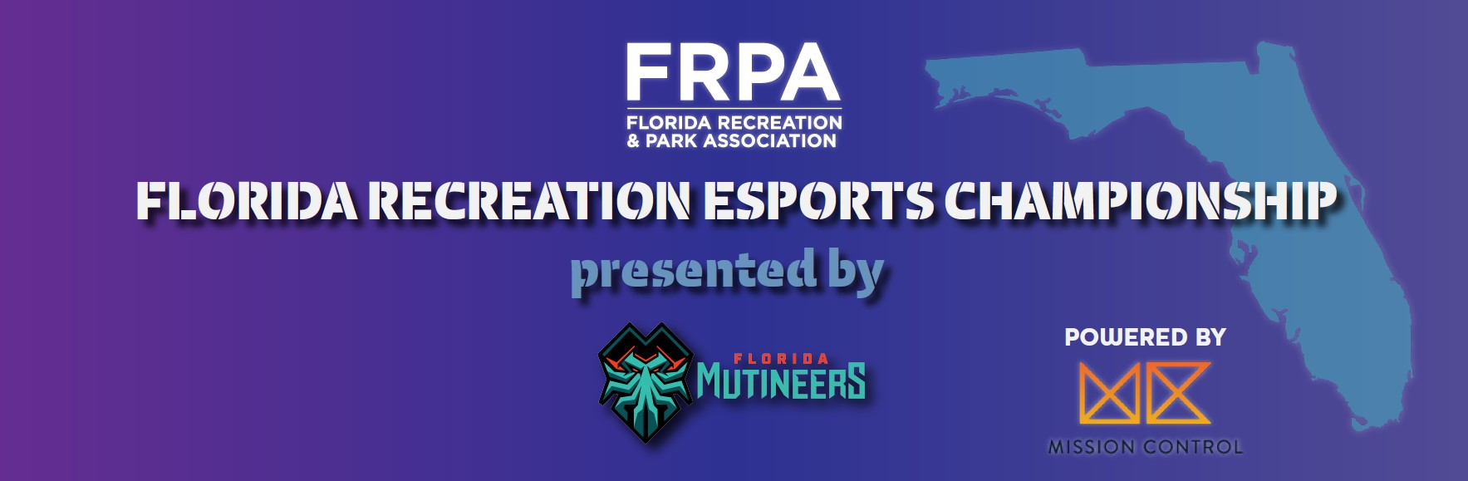
Welcome to the first ever Florida Recreation Esports State Championship!
Only Florida park and recreation departments can enter teams into the Florida State Championship. All players must be listed on a registration form provided by a registered park and recreation department. Players will compete in the championship on the Mission Control platform. Complete roster is due to the FRPA state office by July 28, 2021 (no late exceptions). FRPA is not responsible for internet quality during games. It is the player's responsibility to ensure they have adequate upload and download speeds to not incur lag or quality issues. Players of all ages are allowed one entry per game.
Agencies can report up to three teams per game (up to 18 players total) to represent their agency; participants can compete on more than one team but cannot play multiple times in one game.
🎮 Fortnite | Duos 🎮 Rocket League | 3x3 play 🎮 Super Smash Brothers | 1v1
Park and Recreation Agency Name
Contact Name
Phone Number
Email Address
Will you/did you use Mission Control for your qualifiers?
TEAM REGISTRATION FEES  (circle one) |  | $150 FRPA Agency Members | $200 non-Members
Card Number
Expiration Date |  |  | CVV Code
Name on Card
Billing Address
Signature
See Official Game Rules for additional information. If you are using Mission Control for qualifiers, see this set of Game Rules.
ROSTER (due to FRPA office by July 28, 2021 at 5pm)
FORTNITE
Team 1
Name |  | Email |  | Username
Name |  | Email |  | Username
Team 2
Name |  | Email |  | Username
Name |  | Email |  | Username
Team 3
Name |  | Email |  | Username
Name |  | Email |  | Username

ROCKET LEAGUE
Team 1
Name |  | Email |  | Username
Name |  | Email |  | Username
Name |  | Email |  | Username
Team 2
Name |  | Email |  | Username
Name |  | Email |  | Username
Name |  | Email |  | Username
Team 3
Name |  | Email |  | Username
Name |  | Email |  | Username
Name |  | Email |  | Username

SUPER SMASH BROTHERS
Team 1
Name |  | Email |  | Username
Team 2
Name |  | Email |  | Username
Team 3
Name |  | Email |  | Username

