Amy Zengotita, Speaker: azengotita@southdaytona.org
Links from the session/chat:
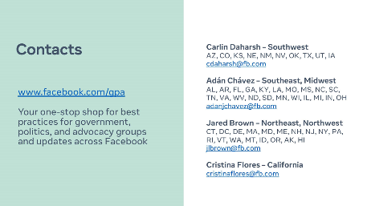
www.facebook.com/gpa/help
canva.com
123RF: https://www.123rf.com/
Visme: https://www.visme.co/
Easil: https://about.easil.com/
Over: https://www.madewithover.com/
Poster My Wall: https://postermywall.com/
Loomly: https://www.loomly.com/
Music:
YouTube Audio Library: https://studio.youtube.com/channel/UCc08XF7Upq-flgERNmGVCbA/music
Facebook Sound Collection: https://business.facebook.com/creatorstudio/?tab=ct_sound_collection&collection_id=all_pages
https://www.storyblocks.com/
https://artlist.io/
https://soundcloud.com/
https://coschedule.com/
https://trello.com/home
www.hubspot.com/email-signature-generator
Social Media Accounts:
@GrandviewParks
facebook.com/grandviewparks
@HarfordCountyPR
Sarasota County Play @SRQCountyPlay
@CityofSIB
@dickinsonparks
High Point Parks & Recreation, NC @highpointparksandrecreation
Ridgewood Parks and Recreation (NJ) : Facebook - Ridgewood Parks and Recreation
@ajparksandrec
https://www.facebook.com/chesternhrecreation
@ormondleisure FB and IG
Somerset County Park Commission
@SafetyHarborRecreation
@TarponSpringsRecreation FB & Insta
@JoplinParks
facebook.com/joplinparksandrecreation
@lakeworthbeachpbc
City of Orangeburg Parks and Recreation Department @orangeburgparks
Ridgewood Parks and Recreation (NJ) : Instagram - Ridgewood.parksandrecreation
@haysvilleks
@nmbafc FB- North Myrtle Beach Aquatic & Fitness Center
@neptunetownship.org
IG: somerset.parks
motivation Monday, talking point Tuesdays, workout Wednesday, thankful Thursday, weekend workout, weekend crafts, schedule Sunday
And remember albums are awesome to use on FB!
@PalmettoBayVlg FB: Village of Palmetto Bay IG:villageofpalmettobay

