Coffee Filter Butterfly Craft

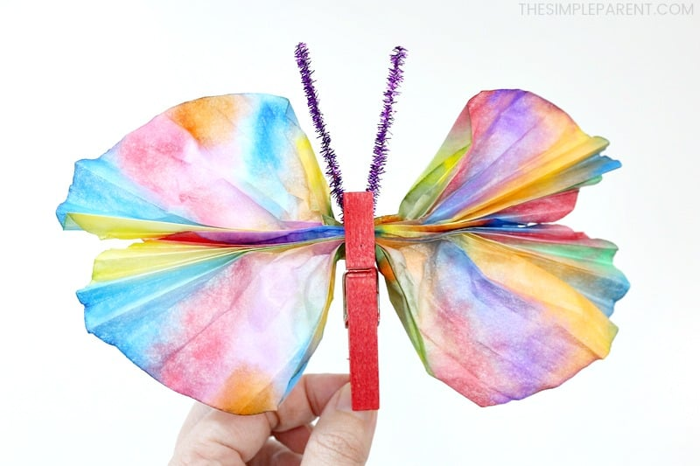
Supplies:
- Coffee filters (2 per Butterfly)
- Washable markers
- Spray bottle with water
- Clothes pin
- Pipe cleaners
- Washable paint brush pens
- Wax paper

Directions:
- Place two coffee filters flat on top of each other on a surface that you don’t mind getting wet. Wax paper works well.
- Use the markers to decorate the top coffee filter. The color will seep through to the second coffee filter too.
- Have your kids color most of the coffee filter with different colors, but they can leave some white parts as well.
- Using a spray bottle filled with water and let your child mist the coffee filter with water. They should spray until the coffee filters are just dampened. If they get too wet, they could be too fragile.
- Pull the two filters apart and lay them out to dry on a piece of wax paper. When they’re completely dry, you’ll have two beautiful filters to make the wings on your coffee filter butterfly!
- While the coffee filters are drying, paint the clothespins. Paint all four sides of each clothespin then set aside and allow to dry completely.
- Once the coffee filters are dry, fold them back and forth like an accordion then pinch them in the middle to hold them together.
- Clip the clothespin onto the center of the coffee filters where you were pinching them.
- Then gently spread the filters to create the four wings of the clothespin butterfly.
- Use half of a pipe cleaner to create the antenna on the butterfly. Bend it in half and then you can bend it or curl it more to create unique butterflies.
- Slip the pipe cleaner into the top of the clothespin to keep the antenna in place.
- Press the end of the clothespin together to make sure it holds on to the pipe

