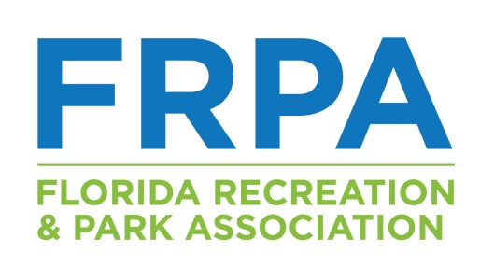
DONOR FORM
ONSITE SILENT AUCTION
December 5, 2023

For inclusion in the Onsite Auction,
this form will need to be returned by December 1, 2023

Organization Donating Item:
Donor Address:
Donor Email:
Item Title:
Item Description:
Item Value:  (minimum value of $40) | $

Return Form/Item to:
Via email: pearson@mydelraybeach.com
Via mail: City of Delray Beach
Attn: Danielle Pearson
50 NW 1st Avenue
Delray Beach, FL 33444
FLORIDA RECREATION AND PARK ASSOCIATION

