May is Mental Health Awareness Month

Week 1: Introduction-Take Time For You
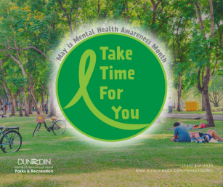
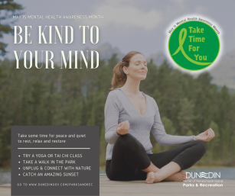
As we recognize May as “Mental Health Awareness Month,” Dunedin Parks & Recreation is here to help you on your journey to living your best life! Throughout the month of May, we will be highlighting various programs and opportunities we offer to help improve your mental health. Now is the perfect time to “Take Time For You.” 💚Learn more here: https://loom.ly/vvKyGSs
#mentalhealthawareness #itstartsinparks #livewelldunedin

Week 2: Be Kind to Your Mind
💚Take some time for peace and quiet to rest, relax and restore your mind and body. Try a Yoga, Tai Chi or Qi Gong class at the Dunedin Community Center or Hale Senior Activity Center. Or get outdoors and enjoy our city parks! Take a nice walk or bike ride, breathe in the fresh air, relieve some stress and connect with nature. 👉Visit www.DunedinGov.com/parksandrec for a list of parks, facilities and programs.
#mentalhealthawareness #itstartsinparks #livewelldunedin

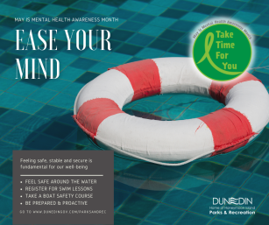
Week 3: Ease Your Mind
💚Anxiety of the most common mental health disorder in the U.S. Feeling safe, stable and secure is fundamental for our well-being. Take action, be prepared and feel safe around the water – register your child for swim lessons at Highlander Pool, take a boat safety course at Dunedin Marina, or attend a Hurricane Preparedness & Safety Seminar at Hale Senior Activity Center. 👉Register online for swim lessons at www.DunedinGov.com/registeronline or call (727) 812-4530 for more information.
#mentalhealthawareness #itstartsinparks #livewelldunedin

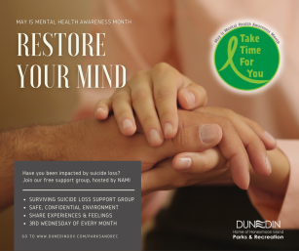
Week 4: Restore Your Mind
💚Have you been impacted by suicide loss? Join our free Surviving Suicide Loss Support Group, hosted by NAMI (National Alliance on Mental Illness – Pinellas County). This peer-led support group is for family members, caregivers and loved ones of individuals who lost their lives to suicide. Meetings are held on the 3rd Wednesday of every month, 6-7:30pm at the Dunedin Community Center. Free to attend. 👉To register, call (727) 492-7452 or email dhandley61@gmail.com.
Dunedin Community Center: 1920 Pinehurst Road, Dunedin FL 34698
#mentalhealthawareness #itstartsinparks #livewelldunedin
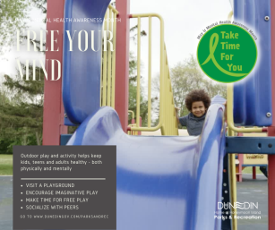
Week 5: Free Your Mind
💚Outdoor play and activity helps keep kids, teens and adults healthy – both physically and mentally. Dunedin Parks & Recreation provides 29 parks and 12 playgrounds to let your child’s imagination and curiosity run wild. Get out and play! 👉Visit www.DunedinGov.com/playgrounds for a list of playgrounds and locations.
#mentalhealthawareness #itstartsinparks #livewelldunedin

