Does an Orange sink or float?

What you'll need:
- An orange
- A deep bowl or container
- Water

Instructions:
- Fill the bowl with water.
- Put the orange in the water and watch what happens.
- Peel the rind from the orange and try the experiment again, what happens this time?

What's happening?
The first time you put the orange in the bowl of water it probably floated on the surface, after you removed the rind however, it probably sunk to the bottom, why?
The rind of an orange is full of tiny air pockets which help give it a lower density than water, making it float to the surface. Removing the rind (and all the air pockets) from the orange increases its density higher than that of water, making it sink.
Density is the mass of an object relative to its volume. Objects with a lot of matter in a certain volume have a high density, while objects with a small amount of matter in the same volume have a low density.

Orange Short Jokes
Why do oranges wear suntan lotion?
Because they peel.
Why did the Orange go out with a Prune?
Because he couldn't find a Date!
What does an Orange sweat?
Orange Juice!
Why did the blonde girl stare at the carton of orange juice?
It said concentrate.
Why did the orange stop rolling down the hill?
Because it ran out of juice!
What did the apple say to the orange?
Nothing stupid, apples don't talk.
Why do the Tennessee Volunteers have orange jerseys?
So they can play the game, direct traffic, and pick up trash without changing.
Where do plastic oranges live?
Orange County.
Why did the orange go to the doctor?
It wasn't peeling well.
What kind of monkey doesn't eat bananas?
An orangutan.
Why did the orange fail his driving test?
He kept peeling out.
How many marmalade sandwiches did Paddington bear eat?
None he was already stuffed.
Do you now why a orange is smart?
Because it CONCERTRATES!
Why did the fruit bat eat the orange?
Because it had appeal.
What do you call a fruit riding a motorcycle?
An Orange County Chopper.
Why did the man lose his job at the orange juice factory?
He couldn't concentrate!
I thought I was drowning in Crush soda, but it was only a Fanta sea
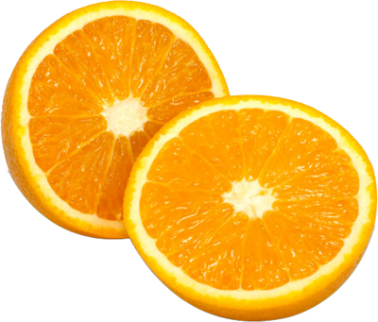
Roses are red
Berries are blue
Oranges are orange thats why there cool

