Skittles Chromatography
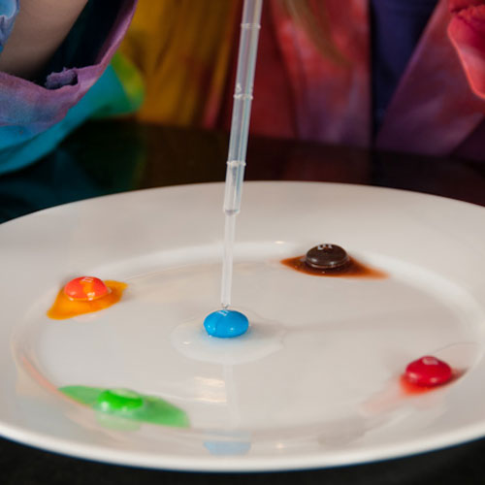
Colorful Candy Kitchen Science

Sick Science! Summer Camp - candy chromatography, floating letters
Many candies on the market today are made with bright dyes and lots and lots of sugar. These things may not be the best for you, but they do make for fun and easy kitchen science.

Experiment Materials
- Petri Dish or shallow bowl
- Filter Paper or coffee filters
- Pipettes or droppers
- Plate
- Clear drinking glass filled with water
- Skittles
- Gobstoppers
- M&M's
- Ruler
- Pencil
- Salt

Skittles Chromatography
- Take out a dinner plate and lay one of each color of Skittles, leaving a little space around each one.
- Using a pipette or dropper, squeeze a little water onto each piece of candy to start dissolving the shell.
- While you wait for the candy to dissolve, cut your filter paper into a square.
- Draw a pencil line about 2 cm from the bottom edge of the paper. Do not use pen, because the ink will run. This is your origin line.
- When the water around the candy has turned color, squeeze the colored water into the pipette bulb.
- Drop a few drops of colored water on the origin line on your filter paper. You may need to add several drops to ensure you have enough dye.
- Repeat this with each color, leaving about 2 cm between each color.
- Let the filter paper dry completely.
- Prepare a salt mixture of 0.1% for the solvent by adding 1/8 of a teaspoon of salt to 3 cups of water (1g of salt to 1L of water)
- Mix until the salt has completely dissolved.
- Pour a small amount of the salt mixture into the bottom of a glass or jar.
- Place filter paper in the glass with salt water so that it is standing up and the bottom is barely touching the surface of the salt solution.
- You can tape the top of the filter paper to a pencil and hang it down into the solution if you have a hard time getting it to stay right at the surface.
- Observe the salt water rising up the paper by capillary action until it is almost at the top.
- Remove the paper from the glass and mark with a pencil where the solvent stopped.
- Let the paper dry completely.
- Repeat the experiment using M&M's, Gobstoppers or other dyed candy and compare like colors. Is the red dye the same in all of the candies, or do the colors run differently?
Do all of the colors move the same distance? You can mark measurements on the filter paper and observe how each color moves and how far.

How Does This Work?
Colorful candies like Skittles are made with FD&C dyes, sugar and other substances. Chromatography is a technique used to separate different parts of a solution. It is used to identify chemicals, used to identify crime scene samples like blood or drugs and used to demonstrate the different dyes in your favorite candy.
If you spill a drop of water on a print out from an InkJet printer, the ink will run. The water will travel through the paper by a process called capillary action. As the water travels, it will pick up particles of the ink and carry them through the paper. This is called paper chromatography. Chromatography works because different parts of a solution, like the water-dye solution you drop on the filter paper, will move differently and at different rates. Some will “stick” to the paper fibers and not spend a lot of time traveling with the water, while others will travel in the water for greater distances. Filter paper works well in this experiment, because it allows water to flow through it easily.

