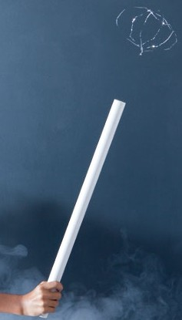
MAKE A LEVITATING ORB! - Science Bob

You will need
- 1 inch (2.5 cm) wide PVC Pipe about 24 inches (60cm) long. You can also use a regular balloon if you do not have PVC pipe.
- Mylar tinsel for Christmas trees. There are many types of tinsel and many will not work – you should look for the thinnest and narrowest possible. The tinsel used in the video is about 1 millimeter wide.
- A head of clean, dry hair
- Scissors

What to do;
- Arrange 6 strands of mylar together and tie them together in a knot at one end.
- Tie them together again about 6 inches (15cm) from the first knot.
- Cut the loose mylar strands off just past each knot.
- Charge the PVC pipe by rubbing it back and forth through your hair for 10 seconds.
- Hold the mylar orb (by the knot) above the charged pipe and let it drop and touch the pipe.
- It should repel away and start floating. If the tinsel keeps sticking to the pipe, the tinsel is probably not thin enough and you will need to try another kind of tinsel or order some from us. (You will usually have to “recharge” the pipe before each levitation.)

How does it work?
It is all about static charges. Similar static charges repel away from each other. When you rub the pipe in your hair you give the pipe a negative static charge. The orb is attracted to the pipe at first because the orb has a positive charge. As soon as the orb touches the pipe, it picks up a negative charge. Since the pipe is negative and the tinsel orb is now negative, they repel away from each other and the orb levitates! The orb will also take on more of a “ball” appearance when charged since all the tinsel strands are repelling away from each other. Did you notice the orb is attracted to other objects around you – including you? That is because most objects (including you) have a positive charge.

MAKE IT AN EXPERIMENT
The project above is a DEMONSTRATION. To make it a true experiment, you can try to answer these questions:
Does the number of mylar strands affect how well the orb levitates?
Do different materials (hair, fur, wool) build up better static charges?
How long does the static charge last / how can you make it last longer?
Do different widths of pipe affect the floating ability of the orb?

