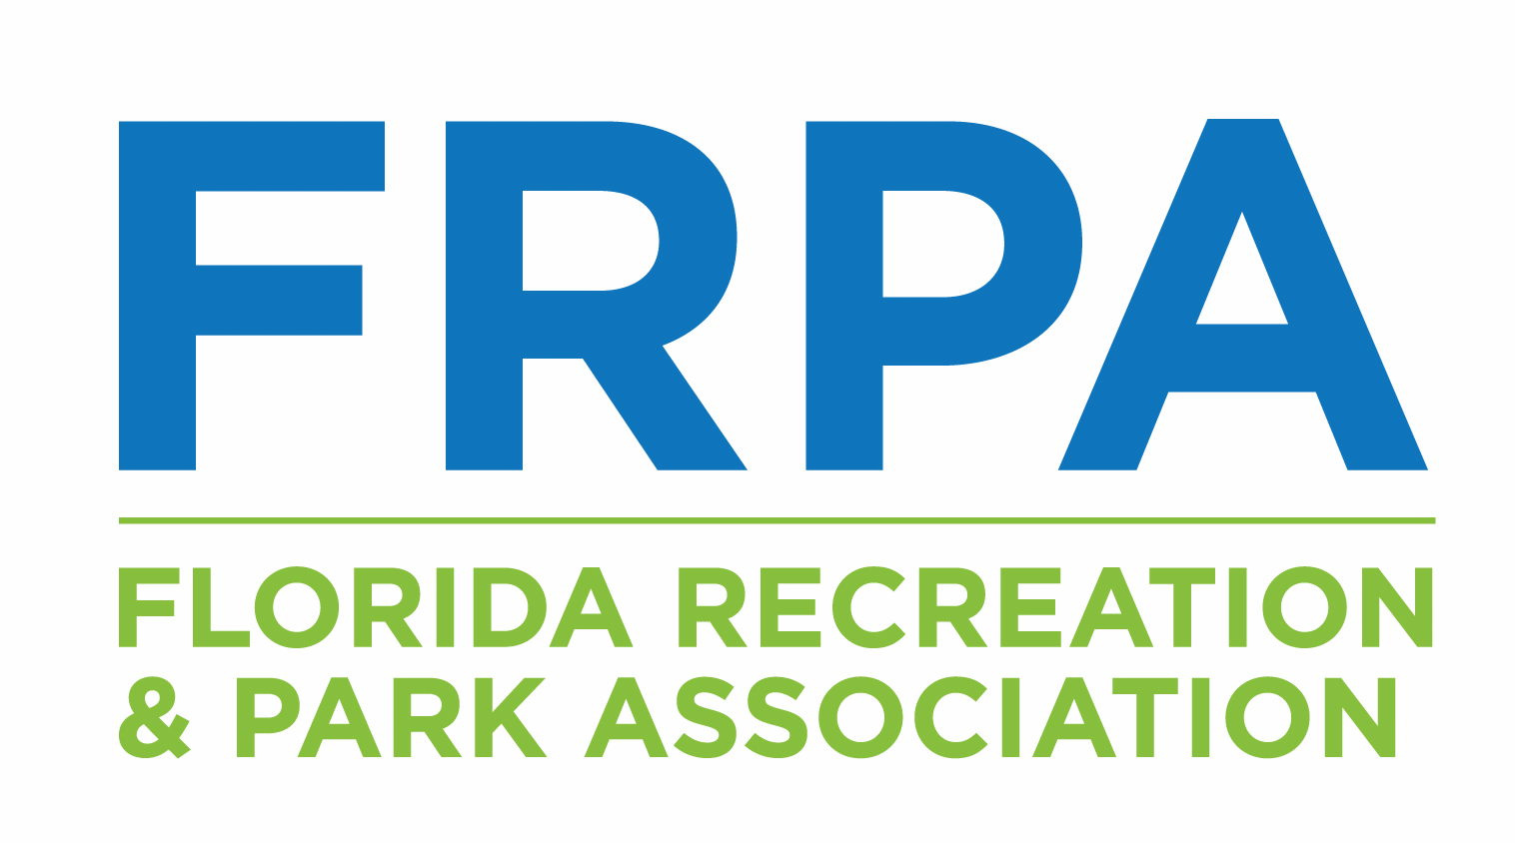
Host Site Questionnaire
Thank you for your interest in hosting an FRPA Education Meeting.

Agency
Contact Name
Phone
Fax
Email

Facility Name:
Facility Street Address:
Facility City and Zip Code:

Is the facility completely ADA compliant (meeting rooms, restrooms, parking, etc.) | Yes | No
(Facilities that are not ADA compliant are unable to be utilized by FRPA for meetings)
Does anyone on your staff speak a language other than English fluently? | Yes | No
(Lets us know the ability of your staff to welcome people in first languages)

Are there any times that this facility is generally not available? (for example, if you host an aftercare program each afternoon from 3-6pm):

Please list the number of meeting rooms available and how many each can accommodate with different set ups.
Meeting Room |  |  | # Theater Set-Up (chairs only) |  |  | # Classroom (chairs/tables) |  |  | # Round Tables
Do you have table cloths or coverings that can be used? | Yes | No |  | Rental Fee $ ___________ |  |  |  | Complimentary
Our Commercial Members sponsor Education Events throughout the state. In exchange for sponsorship, they are allowed to set up a tabletop display onsite at the event.  Does your facility have space for this? |  |  |  |  | Yes |  | No
If so, what room do you suggest from the list above?
Are you able to provide six or eight foot tables for this?

Are there any facilities or areas of interest where an off-site tour may be offered? | Yes | No
If yes, please provide names of facilities with contacts who can provide additional information.
Is there a caterer that we are required to use if we are doing a meal function? | Yes | No
Please attach a list of required or recommended caterers with their phone and area code.

Does your facility/agency have an ASCAP/BMI License? |  | Yes | No
What is the parking arrangement for the meeting attendees (on-site free parking, fee parking, walking distance from parking etc.)?

Please check off each duty that your agency can fulfill:
Provide a meeting room for the meeting coordinators’ pre-event planning meeting
Provide a staff liaison to coordinate the event with FRPA Staff
Provide staff as speakers for educational sessions for the meeting
Assist in arranging lunch
Provide set-up and tear-down of meeting rooms
Provide signage or maps, entrance signs, directional signs, session signs for meeting rooms.

Please indicate audio visual equipment you can provide by listing how many of each are available and costs (if none, place a 0 in # Available).
Equipment |  |  | # Available | Costs to use
Screen (pull up / portable)
Screen (permanent)
LCD Projectors
Laptop Computers for LCD projectors
Overhead Projector
Flip Charts/markers/easels
Extension Cords
Power strips to run from outlets to equipment
TV/VCR
TV/DVD
Slide Projector
Microphone and podiums
Lavalier (lapel) microphone and sound
Internet Access | Yes | No | Wifi | Yes | No

Cost for using this facility
Meeting Rooms
Set up
Parking
Other
TOTAL COST

Do you have suggestions for any local business that may be willing to sponsor a portion of the meeting? If so, please list:

Please list/elaborate on other items/concessions that you can provide such as light breakfast, snacks, coffee, juice, water, etc. for meeting attendees: (This is not a requirement, but is an added value to meeting attendees and therefore may be considered in the selection of a site.)

In exchange for complimentary use of facility you may select one of the following options: (please indicate which best suits your needs)
5 free meeting registrations
Non-member staff may attend @ the member rate.

FRPA has specific policies that are applied to commercial vendors/suppliers at our Education Meetings. By signing below, you agree that you will not invite vendors to be present at the facility during the time the FRPA meeting is being held. Vendors should be referred to the FRPA Executive Office who will convey how the vendor can be involved with or at the Meeting.

_____________________________________ ______________________________________
Signature of Agency Representative Printed Name of Agency Representative

Florida Recreation and Park Association
411 Office Plaza Drive | Tallahassee, FL 32301
P: (850) 878-3221 | F: (850) 942-0712

