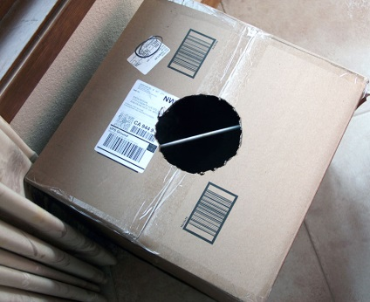
VORTEX BOX
Materials needed
- Fog Machine and Juice – you can see the science but will work without fog
- Boxes
- Duck or masking tape
- Cups or something to knock over
- Utility Knife – Adult use only

In this experiment you can build a vortex device (vortex cannon) to create a pressure wave that transmits a lot of energy! We used one to set up our own real-life Angry Birds game.
The first thing you need to do is get a big cardboard box (bigger the better)…we used 12x12x12 in. Close the box and seal all of the seams with tape. You want to make sure that you get the box to be as air tight as you can. Then, cut a hole on one side…about 5-6 inches wide.
Fill with fog from a fog machine
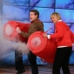
Tap the sides equally with a quick thump

GO BIGGER
The trash can smoke ring generator is a signature finale in Steve Spangler's stage show... and was recently featured on the Ellen DeGeneres Show. Years ago, toy manufacturers like Wham-O sold air blasters that sent bursts of air sailing across a room to the surprise and delight of any innocent victim. With a little practice, it was quite easy to shoot a cup off of someone's head from 20 feet away. Steve Spangler took this to the next level using his motto, "Make it big, do it right, give it class!" His Trash Can Smoke Ring Launcher is easy to make and a blast to share with your friends.

Materials
- 5 gallon bucket or a large trash can
- Bungee cord Plastic
- shower curtain or thick plastic sheet
- Knife or keyhole saw

Experiment
- It's easy to make your own air blaster using materials that you can find at the hardware store. Start with a 5 gallon plastic bucket (about $3 in any hardware store). Carefully cut a 2 to 3 inch hole in the bottom center of the bucket.
- Stretch a membrane across the top of the bucket. Believe it or not, a piece of clear plastic shower curtain works great. Just stretch a piece of the shower curtain over the top of the bucket and secure it in place using a bungee-type cord.
- Lightly hit the shower curtain with your hand or the end of a stick. An invisible blast of air shoots out of the hole. Just aim the air cannon at someone or something across the room and send a blast of air their way with a whack of the membrane.

How to Make a Smoke Ring Launcher
How can you make the invisible ring of air visible? With a little smoke, of course. The best smoke rings are made by filling the trash can with theatrical smoke. Smoke machines (foggers) are commonly used in stage productions. Check to see if your theater department has one, or see if you can borrow one from the disc jockey who plays for your school dances.
The best smoke rings are also made by gently tapping the shower curtain. A hard smack results in a fast blast of air that is difficult to see. The flying vortices are best seen against a dark background with light coming from either side.

4th of July Smoke Bomb Twist
The smoke machine is the traditional way of creating smoke rings in your air blaster, but there's no need for a smoke machine when smoke bombs are readily available around the 4th of July. After lighting the smoke bomb (with adult supervision, of course), fill the trash can with the colored smoke. Use caution as hot debris can shoot up from the smoke bomb and burn tiny holes in the membrane. The trash can is ready for you to tap the membrane and produce dozens of colorful smoke rings.
Whether you choose the more traditional smoke machine or the much more exciting smoke bomb, the rule is the same - never blow smoke in anyone's face (people or animals!) Aim the flying rings of smoke in the air and fire away. We also recommend that you do this activity outside or be prepared for the smoke alarms to go off. It's always interesting to have to explain the smoke rings to the fire department, especially when the rings are created by smoke bombs... been there, done that.

How Does It Work?
The proper name for the air cannon device is vortex generator. The "ball" of air that shoots out of the cannon is actually a flat vortex of air, similar to rings of smoke blown by a talented cigar smoker. A vortex is generated because the air exiting the bucket at the center of the hole is traveling faster than the air exiting around the edge of the hole. That swirling or vortex motion can be observed if a little smoke is blown into the bucket just before giving the rubber membrane a gentle push. This activity demonstrates that air occupies space... and the flying smoke rings are an added bonus.

