FRPA FOUNDATION AUCTION BASKETS OF FUN DONATION

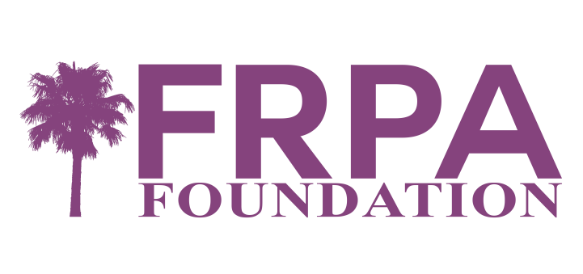

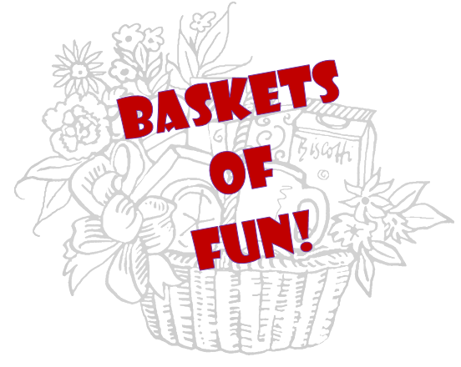
The FRPA Foundation is hosting a basket auction leading up to the 2022 FRPA Annual Conference. This Auction will take place August 15th-30th online. The theme is “Love Your Community”! Agencies are encouraged to put together a fun basket that would entice others from around the state to come visit your community. This can include attractions, hotel stays, unique experiences, parks (naturally), and more! Ribbons will be awarded in the following categories: Most Creative, Most Unique, and Most Popular. A Grand Prize of $200 will be given to the agency who prepares the basket that receives the largest percentage of value bid to use as they wish!

Parameters:
- Basket should have a minimum value of $100
- A picture should be sent to FRPA by August 1, 2022
- Also send pictures of certificates before putting the basket together
- Gift certificates or vouchers should expire no earlier than August 31, 2023
- Please communicate any unique requirements for redeemer to use items (contacts, dates, requests, etc.)

FRPA FOUNDATION AUCTION BASKETS OF FUN DONATION FORM

For inclusion in the Auction, this form will need to be returned by August 1, 2022.

Agency donating basket:
Contact Person:
Address:
Email:
Basket Title:
Basket Description (up to 50 words. Include expiration dates, if applicable):
Basket Value: | $

___________ I will hand deliver my basket at the FRPA Conference.
___________ I will mail my basket to FRPA ahead of the Conference (must be received by office by August 12).

Return Form/Item to:
Email: charla@frpa.org
Fax: 850-942-0712
US Mail: FRPA Foundation Auction Donation
411 Office Plaza Drive
Tallahassee, Florida 32301-2756

FLORIDA RECREATION AND PARK ASSOCIATION FOUNDATION, INC.

