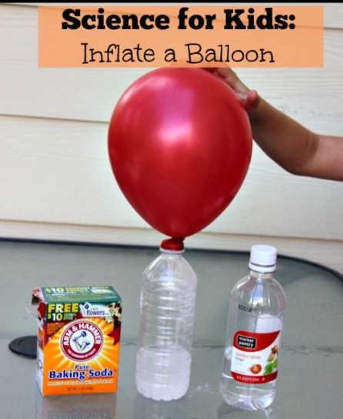
Balloons - BUILD A FIZZ INFLATOR

You will need
- One small empty plastic soda or water bottle
- 1/2 cup of vinegar
- Small balloon
- Baking soda
- Funnel or piece of paper

What to do
- Carefully pour the vinegar into the bottle.
- This is the tricky part: Loosen up the balloon by stretching it a few times and then use the funnel to fill it a bit more than half way with baking soda. If you don’t have a funnel you can make one using the paper and some tape.
- Now carefully put the neck of the balloon all the way over the neck of the bottle without letting any baking soda into the bottle.
- Ready? Lift the balloon up so that the baking soda falls from the balloon into the bottle and mixes with the vinegar. Watch the fizz-inflator at work!
- How does it work?
- The baking soda and the vinegar create an ACID-BASE reaction and the two chemicals work together to create a gas, (carbon dioxide) Gasses need a lot of room to spread out and the carbon dioxide starts to fill the bottle, and then moves into the balloon to inflate it.

MAKE IT AN EXPERIMENT
The project above is a DEMONSTRATION. To make it a true experiment, you can try to answer these questions:
Does water temperature affect how fast the balloon fills up.
Does the size of the bottle affect how much the balloon fills?
Can the amount the balloon fills-up be controlled by the amount of vinegar or baking soda?

