**Design and Test a Parachute**

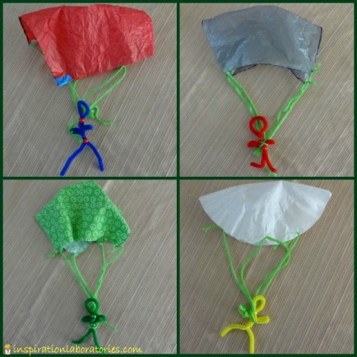Learn about air resistance while making an awesome parachute! Design one that can fall slowly to the ground before putting it to the test, making modifications as you go.

**What you'll need:**

* A plastic bag or light material
* Scissors
* String
* A small object to act as the weight, a little action figure would be perfect

**Instructions:**

1. Cut out a large square from your plastic bag or material.
2. Trim the edges so it looks like an octagon (an eight sided shape).
3. Cut a small whole near the edge of each side.
4. Attach 8 pieces of string of the same length to each of the holes.
5. Tie the pieces of string to the object you are using as a weight.
6. Use a chair or find a high spot to drop your parachute and test how well it worked, remember that you want it to drop as slow as possible.

**What's happening?**

Hopefully your parachute will descend slowly to the ground, giving your weight a comfortable landing. When you release the parachute the weight pulls down on the strings and opens up a large surface area of material that uses air resistance to slow it down. The larger the surface area the more air resistance and the slower the parachute will drop.

Cutting a small hole in the middle of the parachute will allow air to slowly pass through it rather than spilling out over one side, this should help the parachute fall straighter.

## Testing Different Parachutes

After making our four parachutes, it was time to test them. We headed outside with a step ladder and let each one of them fall.

What else could you test?

* parachute material type {cloth, paper, plastic – even different types within these}
* string type {yarn, ribbon, twine, etc.}
* parachute material size
  + Do larger parachutes work better? Do they result in a slower descent?}
* string length
* type of weight or amount of weight
  + Change the person/weight attached to the strings. What happens?
* height of release
* wind conditions