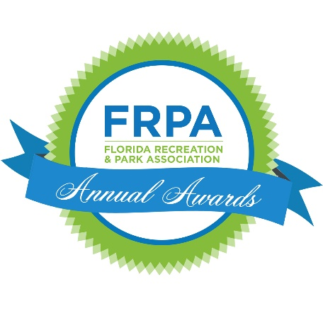
Social Media
FACEBOOK: @FloridaRecreationandParkAssociation
TWITTER: @FRPA_
INSTAGRAM: @isiparks
#FRPA #ItStartsInParks #FRPA21

Example Tweets/ Facebook Posts
Use the text below and tag us in your posts on Twitter and Facebook! FRPA will also do posts about award winners so please be sure to like and share.
[AGENCY/INDIVIDUAL NAME] won the 2021 FRPA Award for [INSERT AWARD NAME IN FULL]! #FRPA #ItStartsInParks #FRPA21
We are excited to announce that [AGENCY/INDIVIDUAL NAME] won the 2021 FRPA Award for [INSERT AWARD NAME IN FULL]! #ItStartsInParks #FRPA21
[AGENCY/INDIVIDUAL NAME] has been named FRPA’s [INSERT AWARD NAME IN FULL] award recipient for 2021! #ItStartsInParks #FRPA21
Congratulations to the 2021 FRPA Award Winners! #ItStartsInParks #FRPA21
[AGENCY/INDIVIDUAL NAME] has joined the list of FRPA honorees receiving the [INSERT AWARD NAME IN FULL] award. #FRPA #ItStartsInParks #FRPA21
Additional Links
frpa.org
frpa.org/awards
Awards
AGENCY EXCELLENCE (IN HEALTH, ENVIRONMENTAL SUSTAINABILITY, ECONOMIC IMPACT; COMMUNITY BUILDING or SUPER categories)
INNOVATIVE PROGRAMMING (IN HEALTH, ENVIRONMENTAL SUSTAINABILITY, ECONOMIC IMPACT OR COMMUNITY BUILDING categories)
PUBLIC RELATIONS
VOLUNTARY SERVICE
CORPORATE SUPPORT
DISTINGUISHED SERVICE
LIFETIME
ACHIEVEMENT
RISING STAR
GOLDEN SHOVEL
SPORTS TOURISM

