Solar Oven Smores

Stevespangler.com
Use energy and heat from the sun to bake delicious snacks in a pizza box
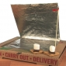
There are just some things that are synonymous with "summertime snacks," and we can't think of a summer snack we enjoy quite as much as s'mores. But what would you do if you weren't allowed to have a fire or just didn't have the tools necessary for a fire? We came up with a pretty neat way to harness the heat and energy of the sun to create a solar powered cooker that makes a delicious batch of s'mores without a fire!

Materials
- Pizza box
- Two clear sheet protectors
- Black construction paper
- Duct tape
- Clear masking or packing tape
- Box knife
- Scissors
- Thermometer (optional)
- Wooden skewer
- Glue stick (Elmer's glue will work, too)
- Tin foil
- Ruler
- Pen

Experiment
- On the lid of a pizza box, use a ruler and pen to measure and draw a square that is 1-2" from the sides of the box.
- Cut along three sides of the square you just made by using box cutters or a pair of scissors.
- Measure and cut a large piece of foil to line the bottom of the pizza box.
- Apply glue to the bottom of the pizza box and glue the large piece of foil into place, smoothing in down.
- Measure and cut another large piece of foil to cover the bottom of the flap you cut on the pizza box lid.
- Apply glue to the bottom of the pizza box lid and glue the tin foil piece into place.
- Use scissors to cut a piece of black construction paper that is 1-2" smaller at each edge than the bottom of the pizza box.
- Use clear masking or packing tape to tape the black construction paper to the bottom of the pizza box. Try to center the black construction paper.
- Find a sheet protector and pull the two pieces apart. Tape these pieces together at one of their long edges. Tape the new, large piece of plastic on the inside of the box lid, NOT the flap. The plastic should span the flap opening. If it doesn't, make a larger plastic sheet!
- Use a wooden skewer to poke two small holes (don't poke the skewer all the way through) on the lid between the flap and the side of the lid. Poke the holes about 2" apart.
- Wrap a thin piece of tape around the skewer, near the flat end, so that one end of the tape is above the other end. Check out the photo at the right to see exactly how to wrap the tape.
- Tape the skewer to the flap so that the flat end of the skewer is near the end of the flap. Use the skewer and the holes you poked in the lid as a kickstand for the flap.
- If you want to see just how hot your Solar Oven gets, tape a thermometer to the bottom of the box so that it can be seen through the plastic window.
- Set up your oven with the flap up and place it in the sun. It may take a little while, but you'll watch your s'mores heat up, melt, and be ready to eat!
Take It Further!
Try making hotter Solar Ovens!
- Use different materials.
- Try different sized boxes.
Is there anything else you can think to change?

How Does It Work?
The Solar Oven is what is more widely known as a solar cooker and works on the principle of converting sunlight to heat energy and retaining the heat for cooking. To make the process work, you cover as much of the box as possible with reflective material in order to catch as much sunlight as possible. In this case, you are using tin foil. The cooking surface is black construction paper because it retains heat very well. If you've ever worn a black shirt on a sunny day, or sat down on the black seat of a car in the summer, you know that black surfaces absorb and retain a lot of heat. Ouch! As heat is retained, the air inside the oven also heats. Next thing you know, you're eating delicious, melt-in-your-mouth s'mores!

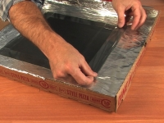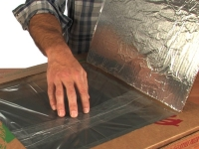
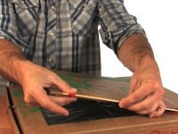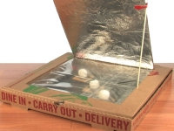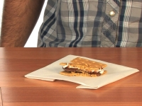
- See more at: http://www.stevespanglerscience.com/lab/experiments/solar-oven#sthash.Xdxj84hf.dpuf

