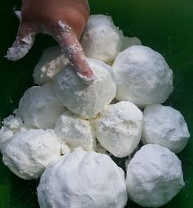
Florida Snow AKA Fluffy Stuff:

- Dump two (2) 16-oz boxes of corn starch into a plastic container.
- plastic box that was about 12-inches wide by 18-inches long by about 4-inches deep. It worked really well.
- Add an entire container of white foam shaving cream. I got the one shown at the dollar store.
- Let the kids mix the corn starch as you add the shaving cream and be prepared with molds if desired. My kids used the shaving cream lid as a mold an just made mountains, a race track, "snowballs" and just had an awesome time with all the good sensory play that comes out of making this concoction.
It really is that easy.
You could also be prepared with a broom and a dust pan to clean up, as this stuff gets everywhere.
You can also save the fluffy stuff in a plastic zippered bag.
Some other notes
- I did this activity OUTSIDE. Just a suggestion on my part.
- The kids played with the corn starch for a couple minutes before adding the shaving cream to see how it feels by itself.
- I made it for the 1st graders one year and the 5th graders came over and played with it for hours. You can always adjust activities to any age group, don’t think just because they are older they don’t want to do it.

