Roll A Picasso

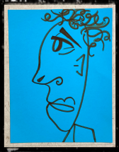
Supplies:
- Cardstock Paper
- Large Die
- Marker
- Picasso Sheets
- Décor Materials

Directions:
- Some may want to play as teams ~ each draw a feature to create one Picasso
- The die and sheet informs which style feature to draw
- Add hair, neck, shoulder(s), etc
