Funny Face Flip Book

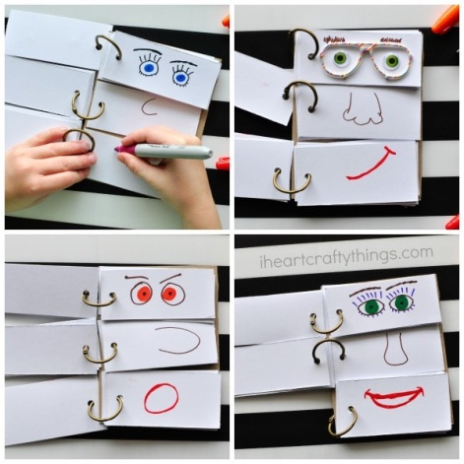
Supplies:
- white cardstock paper
- cardboard
- 3 metal book rings or Pipe Cleaners
- hole punch
- markers
- scissors
- glasses stickers or googly eyes (optional)

Directions:
1. Cut your white cardstock paper into quarters. Do this by cutting a sheet in half and then both of those pieces in half again. Now cut out a piece of cardboard the same size as your cardstock pieces.
2. Cut each of your white cardstock pieces into thirds. To do this, cut your quarter pieces to 5 1/4″ length, then cut each of the three sections at 1 3/4″ length.
3. Punch a hole in one end of each of your pieces with your hole punch. Then, lay three pieces onto your cardboard so you can punch a coordinating hole into the cardboard for each of the pieces. Attach all of your cardstock pieces to your cardboard backing with your metal book rings.
4. Now the fun part begins. Use your markers to draw facial features on your white cardstock pieces. In the top sections draw eyes, in the middle sections draw noses and in the bottom sections draw mouths. You can get extra creative by adding details like eyelashes, eyebrows, teeth, tongue, etc. We had some scrapbooking stickers on hand that had fun glasses stickers so we used them along with some googly eyes for one of our faces.
5.When you are all finished drawing out all of your different facial features flip through your DIY funny face flip book to combine different features together to make silly faces. This makes a really fun combined family activity too. Everyone can take a turn to draw facial features and afterwards take turns combining everyone’s features together for a night of laughter and fun.

