Glow in the Dark Slime

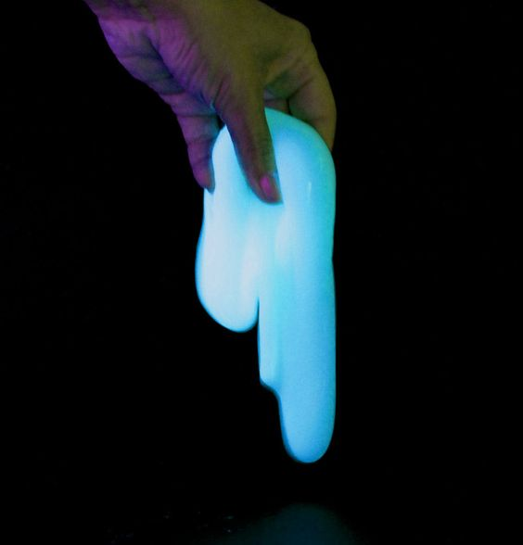
Supplies:
- Elmer's glue gel
- 4% (saturated) borax solution
- glowing paint
- Measuring cups/spoons
- Bowl or zip-top plastic baggie
- Spoon (optional)

Directions:
- Basically, you make glowing slime by adding zinc sulfide or glowing paint to normal slime. These instructions make a clear slime that glows in the dark. However, you could add zinc sulfide to any of the recipes for slime with different characteristics.
- The slime is made by preparing two separate solutions, which are then mixed. You can double, triple, etc. the recipe if you want more slime. The ratio is 3 parts PVA or glue solution to 1 part borax solution, with a little glow-in-the-dark agent thrown in (measurement isn't critical).
- First, let's prepare the glue gel or polyvinyl alcohol (PVA) solution. If you have polyvinyl alcohol, you want to make a 4% polyvinyl alcohol solution. 4 grams of PVA in 100 ml of water is great, but the project still works if your solution is a different percent of PVA (just takes more or less). Most people do not have PVA sitting around their homes. You can make a glue gel solution by mixing 1 part of glue gel (either clear or pale blue) with 3 parts of warm water. For example, you could mix 1 tablespoon glue with 3 tablespoons warm water, or 1/3 cup glue with 1 cup of warm water.
- Stir the glow agent into the glue gel or PVA solution. You want 1/8 teaspoon of zinc sulfide powder per 30 ml (2 tablespoons) of solution. If you cannot find zinc sulfide powder, you can stir in some glow-in-the-dark paint. You can find glowing paint at some paint stores or glowing paint powder (which is zinc sulfide) at craft or hobby stores. The zinc sulfide or paint powder will not dissolve. You just want it mixed in really well. Please read the label on the paint to make sure it is safe enough for your purposes.
- The other solution you need is a saturated borax solution. If you are in a chemistry lab, you can make this by mixing 4 g of borax with 100 ml warm water. Again, most of us aren't going to be doing the project in a lab. You can make a saturated borax solution by stirring borax into warm water until it stops dissolving, leaving borax at the bottom of the glass.
- Mix together 30 ml (2 tablespoons) of PVA or glue gel solution with 10 ml (2 teaspoons) of borax solution. You can use a spoon and a cup or you can just squish it together with your hands or inside a sealed baggie.
- The phosphorescent glow is activated by shining a light on the slime. Then you turn out the lights and it will glow. Please don't eat the slime. The slime solution itself isn't exactly toxic, but it isn't good for you, either. Zinc sulfide can be irritating to the skin, so wash your hands after playing with this slime. It may be harmful if swallowed, not because ZnS is toxic, but because it can react to form hydrogen sulfide gas, which isn't great for you. In a nutshell: wash your hands after using the slime and do not eat it. Do not inhale or ingest the glow-in-the-dark ingredient, whichever you choose to use.
- Store your slime in a baggie or other sealed container to keep it from evaporating. You can refrigerate it if desired. The slime cleans up well with soap and water.

