Spider Web Craft
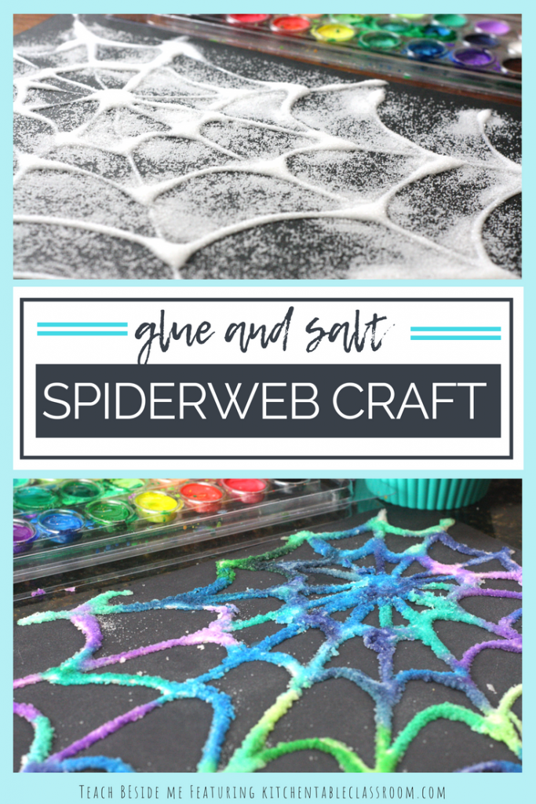
Supplies:
- Salt
- Glue
- Paint
- Paint Brush
- Black construction paper

Directions:
- Start by drawing a dot with a pencil for the center of the spider web. Draw lines freehand or with a ruler that intersect the center point and go from one edge of the paper to the other. It is better to err on the side of fewer lines rather than too many as the glue will make the lines thicker.
- Use your pencil to draw curved lines between each “ray” of the spider web. Again, encourage kids to make these lines farther apart than they might if they weren’t being traced with glue.
- Trace each long ray of the spider web with glue then move on to the curved lines that connect the rays. The lines will be the smoothest if the lid of the glue bottle doesn’t touch the paper. You could even do a practice run in which kids get to make a drizzled free form design before they move onto their spider web.
- While the glue it still wet give each child a ramekin of table salt. Use two fingers to pinch the salt and sprinkle it on top of the wet glue. Cover the glue with salt completely and gently slide off the extra. The spider web will need to dry before moving onto the next step. Dry time is usually overnight but depends on humidity levels as well as the thickness of the glue lines
- When your spider web is dry it’s time to add some color. Using a soft brush, plenty of water, and watercolor paints add a drop or two of color to a salt line. Drop and dab the paint. No scrubbing or the salt and glue will melt away, dissolving your spider web. A light touch is crucial! Watch the color spread down the line of glue and salt. Even on dark paper the color is vibrant and has a “pop.” Encourage kids to use different colors next to one another and watch as they overlap and blend together.

