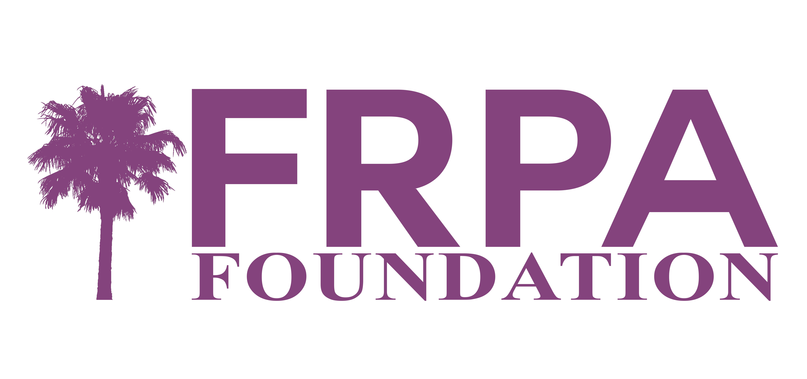
2024 Julia Jones Memorial Scholarship
for Applicants of the Abrahams-Jones Academy for Leadership Excellence

The intent of the Julia Jones Memorial Scholarship is to provide financial assistance to persons wishing to attend the Abrahams-Jones Academy for Leadership Excellence, a program of the Florida Recreation and Park Association.

Julia Jones served as a parks and recreation professional for over 40 years. She served a number of Florida agencies over the three decades she worked in Florida. Julia retired in 2021 from the City of Cape Girardeau, Missouri, where her historic family home was located. Shortly after her retirement Julia passed away, and a scholarship fund has been created to honor her commitment to creating and establishing the Academy.

History of Julia’s work on the Academy
FRPA began work on the concept for a leadership academy to develop future Directors in 1996. Then FRPA President Elect, Julia Jones made this a priority and began conducting research on other state association programs. During her Presidency in 1998 Jones led a work group that was named to develop the concept, curriculum, faculty, etc. In 2008, the first Abrahams Academy was held. Julia, after having spearheaded this initiative for ten years, shared the role of Lead Faculty with Karen Palus. They both served the Academy until 2012 when both left the State of Florida to pursue Director positions in Missouri and Colorado respectively.

Julia’s passion was assuring that parks and recreation was recognized as an integral part of every community. Her belief was the cornerstone of that effort; developing the professionals who will be stewards of the industry in the future. Her dedication culminated in the creation of the Academy and her desire was that it would continue in perpetuity.

The Julia Jones Memorial Scholarship is funded through designated donations to the Florida Recreation and Park Association Foundation.

A scholarship review committee is comprised of two representatives from the Florida Recreation and Park Association Board of Directors, two representatives from the Florida Recreation and Park Association Foundation Board of Directors, and the Founder of the Scholarship Fun or their appointed representative.

Applications will be reviewed for demonstration of the applicant’s dedication to their professional development and growth, their passion for the parks and recreation, leadership experience, and overall commitment to excellence.
2024 Julia Jones Memorial Scholarship Application
(Applications must be typed)

Name:
Street Address:

City/State/Zip:

Phone w/Area Code:
Email Address:

Current Agency:

Current Title:

Please document your employment history by including employer, dates with each employer, titles for the positions you served, and general responsibilities. (A resume can be attached if it includes the stated information.)

Summarize professional development/growth opportunities in which you have participated in the last ten years.

Please list any public speaking you have done to promote or advance the field of parks and recreation.

Please list what leadership opportunities you have had in local/community, state or national organizations in the last ten years (this may be professional organizations, civic organizations, or community based organizations). List organization, leadership position, and dates:

Please provide in no more than 1500 words, what you believe leaders must have to effectively lead in the parks and recreation industry.

Please respond with no more than 1500 words addressing how you believe your attendance at the Abrahams-Jones Academy for Leadership Excellence will benefit you as you continue to excel in your career.

Financial Assistance: Below are anticipated registration and hotel costs for the 2023 Abrahams-Jones Academy. Please place an amount for your transportation in the table below. For all costs, indicate the amount you will be paying and/or the amount your agency will be paying in the table below. Total the columns for the amount you will be paying, and the column for the amount your agency will be paying. Place those totals on the row titled TOTALS.

COST: | AMOUNT PERSONALLY PAYING | AMOUNT AGENCY PAYING OR OTHER FUNDING SOURCES
Registration – anticipated cost $1600 members, $1700 non-members
Hotel – Session 2 – anticipated cost $170 per night – 3 nights required
Transportation – Session 1 – Umatilla, FL
Transportation – Session 2 – Orlando, FL
TOTALS:

Of the above costs that you are personally paying, what amount MUST you have in order to attend the Abrahams-Jones Academy? $ ____________________

Is your attendance at the Abrahams-Jones Academy dependent on receiving the funding amount listed above?
_____ Yes _____ No

Submit Your Completed Scholarship Application in addition to the following to eleanor@frpa.org no later than December 5, 2023
- One letter of reference from an individual that can attest to your commitment to professional development
and leadership; and
- Your completed registration application for the Abrahams-Jones Academy
- Combine the application and any attachments as one pdf document.

The Review Committee will correspond with scholarship applicants on funding awards by December 20, 2023.

