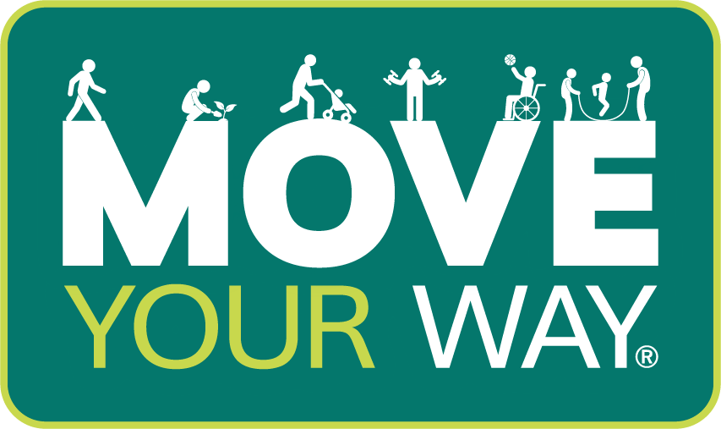

Youth Sports

Social Media Toolkit for Partners
May 2022

Overview
The Office of Disease Prevention and Health Promotion (ODPHP) has developed sports-specific Move Your Way® campaign products for parents of children and adolescents ages 6 to 17 years. These products will promote key messages from the Move Your Way campaign and the National Youth Sports Strategy to encourage youth sports participation as a form of physical activity.

Use these sample social media messages and newsletter content to spread the word about the new products.

Note that for Facebook messages, a dropdown menu will appear after you type @HHSHealthGov. Use this menu to tag the Health.gov Facebook page before you post.

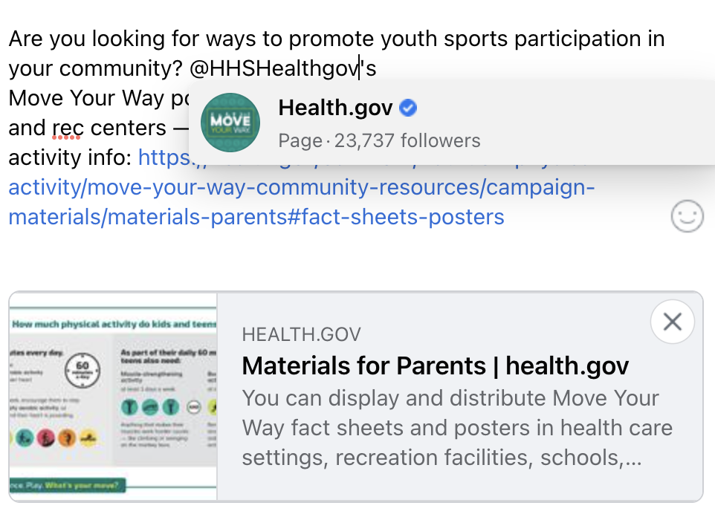
Use these sample Twitter and Facebook messages below to promote the launch of the sports-specific Move Your Way® campaign products for parents. Pair your messages with the social media graphics attached.
Promotional Graphics

Fact Sheet Thumbnail “Find Your Own Way to Play” graphic
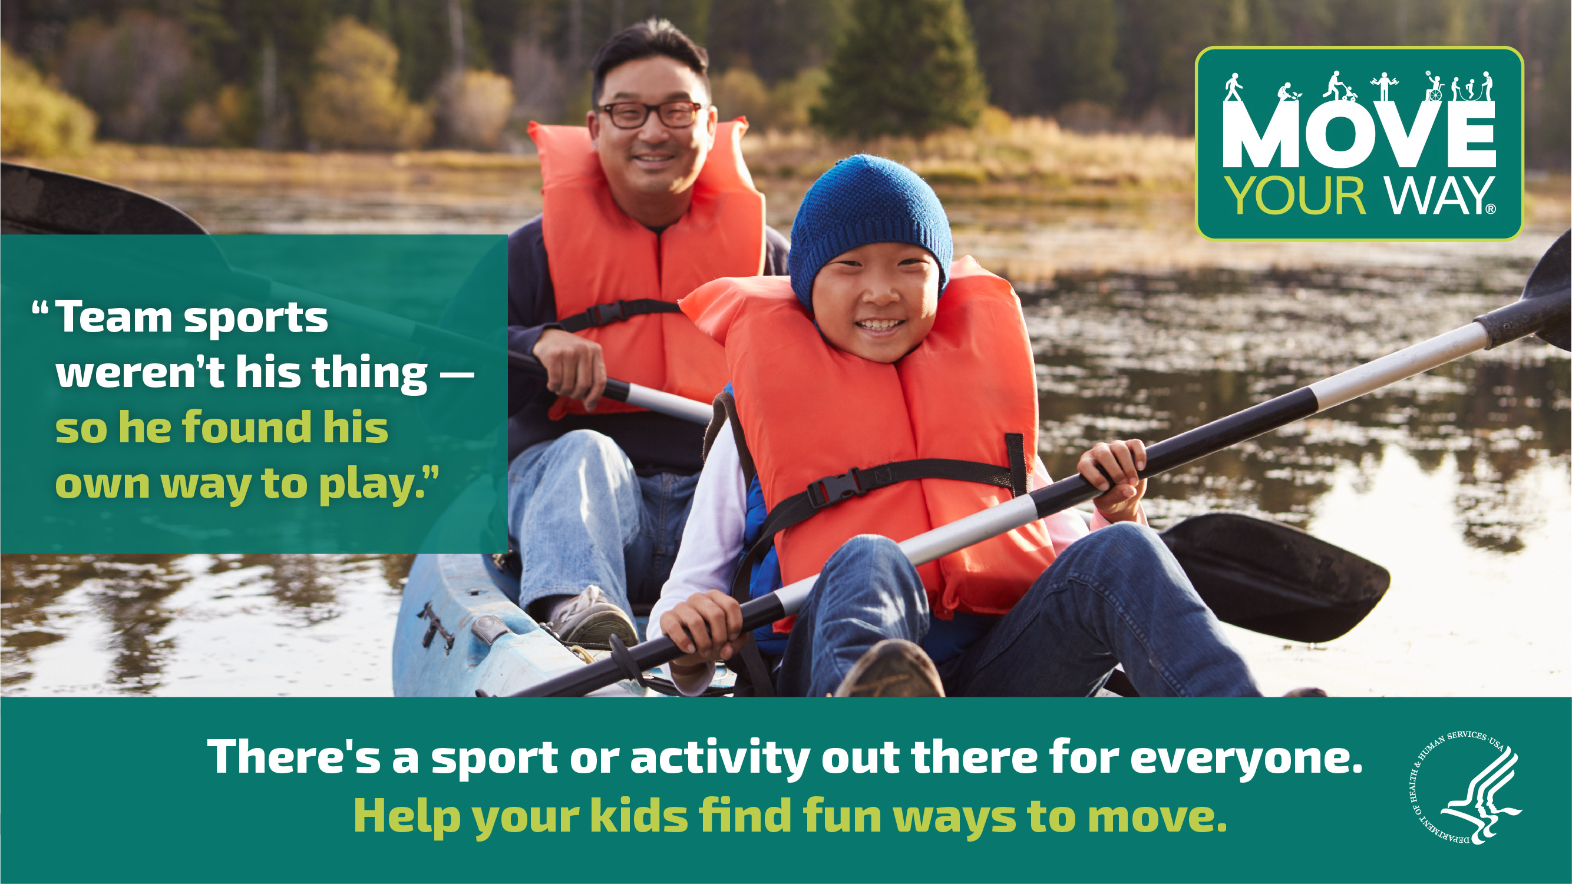
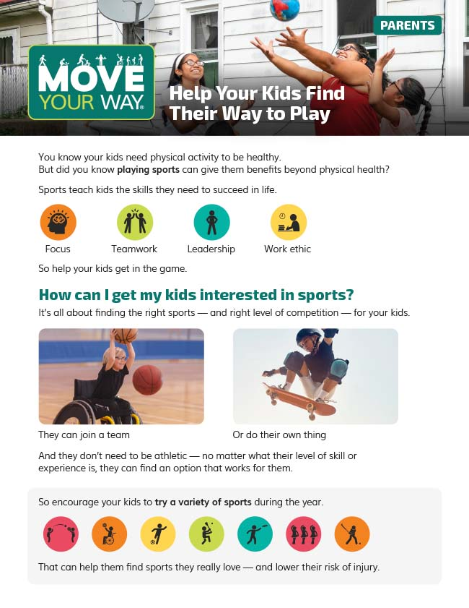

“Focus on Fun” graphic “More Than Just a Workout” graphic
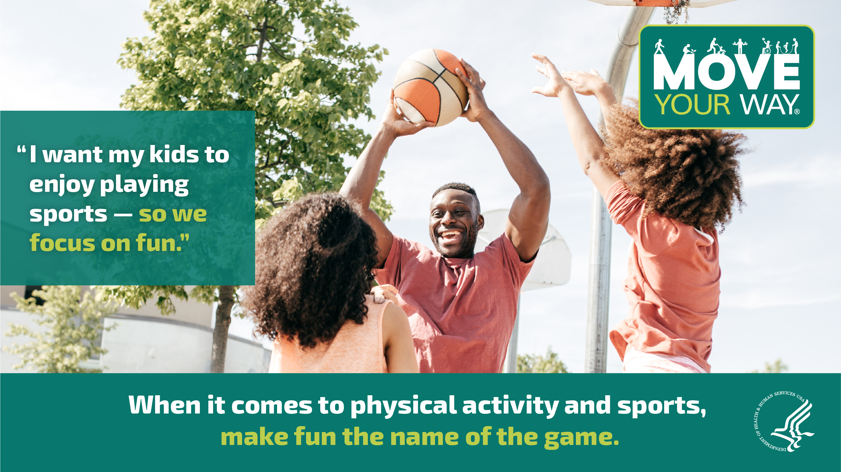
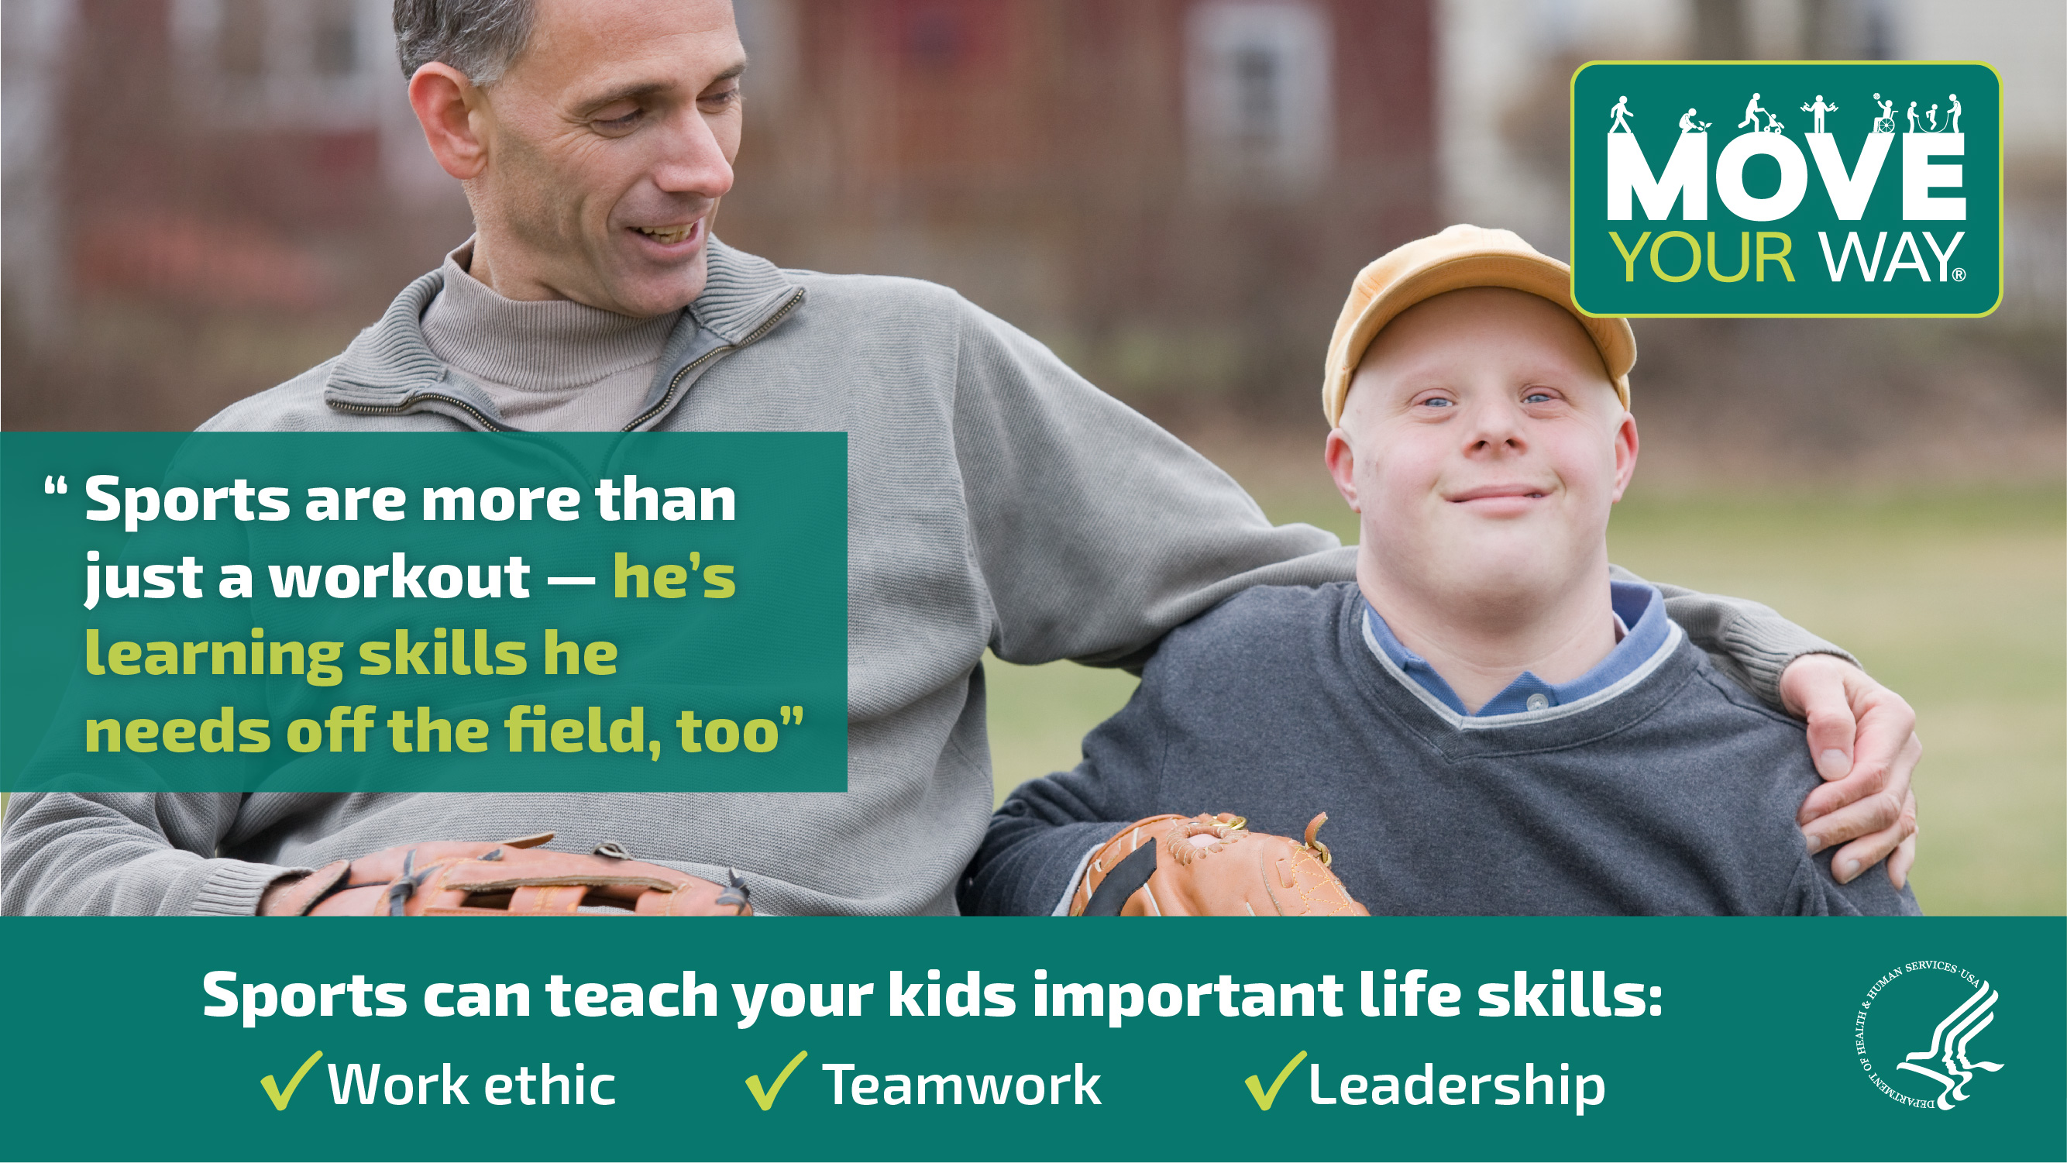

Sample Twitter Content

- #DYK? #YouthSports can teach kids skills they need off the field, too! Learn more with @HealthGov’s new #MoveYourWay video: https://bit.ly/3LCwRG4 [video preview — no graphic needed]

- Parents: #PhysicalActivity and #YouthSports have benefits for kids that go way beyond physical health. Watch @HealthGov’s new #MoveYourWay video to learn more! https://bit.ly/3LCwRG4 [video preview — no graphic needed]

- Make #PhysicalActivity and sports fun for your kids! Check out this #MoveYourWay fact sheet from @HealthGov for tips to help your kids get in the game: https://bit.ly/3wjwHPp #YouthSports [Fact Sheet Thumbnail]

- Encourage parents in your community to get their kids involved in #YouthSports. Share @HealthGov’s #MoveYourWay fact sheet with tips on making sports part of the family routine: https://bit.ly/3FRnzVa [Fact Sheet Thumbnail]

- Want to promote #YouthSports in your community? Share this #MoveYourWay fact sheet from @HealthGov to help parents get their kids involved in sports: https://bit.ly/3NmYkMW [Fact Sheet Thumbnail]

- Parents: Want to help your kids #GetActive? Get them involved in #YouthSports! Check out this #MoveYourWay fact sheet from @HealthGov for tips to help kids find their way to play: https://bit.ly/3lh9uHc [“Find Your Own Way to Play” graphic]

- #DYK that the benefits of #YouthSports go way beyond physical health? Check out this #MoveYourWay resource from @HealthGov to learn more: https://bit.ly/3wCnocp [“More Than Just a Workout” graphic]

- Want your kids to love sports? Focus on fun! Check out @HealthGov’s #MoveYourWay resources to learn about the benefits of #PhysicalActivity and #YouthSports! https://bit.ly/3lhJviL [“Focus on Fun” graphic]

- Encourage families in your community to get their kids involved in sports! Display @HealthGov’s #MoveYourWay posters to spread the word about the benefits of #YouthSports and #PhysicalActivity: https://bit.ly/38DGOFw [“More Than Just a Workout” graphic]

Sample Facebook Content

- DYK? Playing sports can help kids succeed off the field, too! Learn about the benefits of physical activity and youth sports participation with @HHSHealthGov’s latest Move Your Way video: https://bit.ly/3LCwRG4 [video preview — no graphic needed]

- Parents: Are your kids getting enough physical activity? Sports are a great way for kids to get active! Check out this Move Your Way fact sheet from @HHSHealthGov for ways to get your kids involved in sports: https://bit.ly/3MnlOli #MoveYourWay [Fact Sheet Thumbnail]

- Want to get your kids involved in sports? @HHSHealthGov offers a Move Your Way fact sheet with tips that can help! Check it out: https://bit.ly/3Loqk1i #MoveYourWay [“Focus on Fun” graphic]

- Parents: Physical activity and youth sports have benefits for kids that go way beyond physical health. Check out @HHSHealthGov’s Move Your Way resources to help your kids find their way to play: https://bit.ly/3Pr9EK1 #MoveYourWay [“More Than Just a Workout” graphic]

- .@HHSHealthGov’s Move Your Way posters are a great way to promote youth sports participation! Check out all the materials and spread the word about the benefits of youth sports: https://bit.ly/3PqaFSC #MoveYourWay [“Find Your Own Way to Play” graphic]

Sample Newsletter Content
Subject: Check out ODPHP’s sports-specific Move Your Way resources for parents!

Body: The Office of Disease Prevention and Health Promotion (ODPHP) provides sports-specific Move Your Way® products for parents of kids and teens ages 6 to 17 years. And you can use these resources to promote youth sports and physical activity in your community!

Move Your Way is the promotional campaign for the second edition of the Physical Activity Guidelines for Americans. The sports-specific Move Your Way resources — including a brand-new video — can help health professionals, schools, and other organizations communicate with parents about the benefits of youth sports.

Display these Move Your Way posters in your office and share this fact sheet to encourage parents to get their kids involved in sports. And be sure to promote the new Play for Fun, Build Skills for Life video on your social media channels to help parents learn about the many benefits of sports that go beyond physical health.

Sign up for ODPHP’s mailing list to get the latest news and updates about physical activity and youth sports delivered right to your inbox.

