Insert your city/county logo here

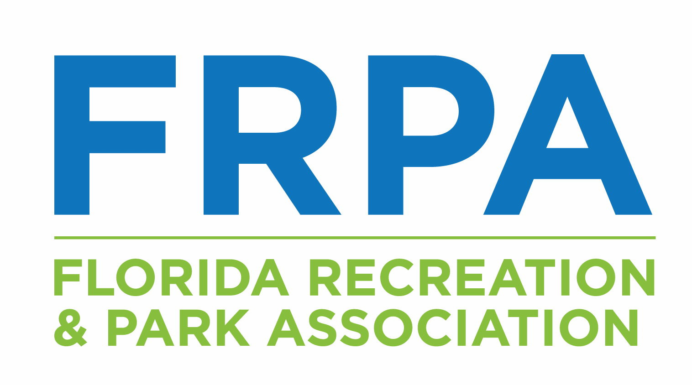
Florida Recreation and Park Association
State of Health and Wellness Pledge

According to the Centers for Disease Control and Prevention (CDC), a healthy community is one that continuously creates and improves both its physical and social environments, helping people to support one another in aspects of daily life and to develop to their fullest potential. Park and Recreation Departments are at the center of healthy places designed and built to improve the quality of life for all people who live, work, learn, and play within their borders—where every person is free to make choices amid a variety of healthy, available, accessible, and affordable options. To show our commitment to community well-being and public health, The Florida Recreation and Park Association (FRPA) created the State of Health and Wellness Pledge. In working to meet the following standards, Park and Recreation agencies can take the lead in moving their community toward a better tomorrow.

Physical Activity
Community
Standard: Park and Recreation agency supports a well-connected community that allows for active transportation.
- Safe, active transportation routes (e.g. bike lanes and walking paths) will be included in plans for all new and redeveloped roadway and park projects.
- Prioritize the support and maintenance of a network of active transportation trails or routes (e.g. establish a program to identify and fill connection gaps and make repairs in the system of sidewalks).

Programming/Policy
Standard: Park and Recreation agency creates an environment of fitness, physical activity and fun while maintaining a safe and positive atmosphere.
Out of School Time Program
- A minimum of 30 minutes per day will be dedicated to outdoor, physical activity at before and after school care programs.
- A minimum of 60 minutes per day will be dedicated to outdoor, physical activity at full day or summer programs.
- Daily physical activity time will include active, aerobic, age-appropriate bone and muscle strengthening and cardio-respiratory fitness activities.
- Structured and unstructured activities will be adaptable, accessible and inclusive of all youth, including those with physical, sensory and intellectual disabilities.
- A variety of physical activity options will be offered that are fun, recreational, life-long learning opportunities.
- No more than 10% of program time will be used for “screen time”. (e.g. access to tv, movies or non-educational related computer devices.)
- Staff will serve as role models for health by leading and participating in active play.
- Staff will not use physical activity as a form of punishment.
- Youth will participate in activity selection, organization and leadership and incorporate child-directed free play.
- Parent/family/community events will incorporate physical activity.
- Annual budget will allow for high quality physical activity experiences.
- Liability and risk management policies will enable staff to participate in physical activity with participants.
- Equipment for games, sports and activities will be age and developmentally appropriate and will support cardio-respiratory and musculoskeletal fitness.
- Safe and adequate indoor and outdoor facilities for physical activity will be provided.
- The self-evaluation process will be ongoing and will include program improvement strategies for physical activity programming.
- Health and wellness classes will be offered at affordable prices and at differing times of day.

Education/Training
Standard: Park and Recreation agency receives up to date training on safe, physical activity and trends in play.
- Staff will receive a minimum of 8 contact hours annually of professional development on effective practices and strategies for planning all-inclusive physical activity.
- Agency will create a staff policy to promote and encourage a physically active lifestyle.

Partnerships
Standard: Park and Recreation agency partners with local organizations to meet the physical activity needs in its community.
- Agency will seek grant funding for programs.
- Agency will partner with the Florida Department of Health local office.
- Agency will be involved in the Community Health Improvement Plan in partnership with the Florida Department of Health local office.
- Agency will be involved in Mobilizing Action through Planning Partnerships (MAPP).
- Agency will encourage and assist local government(s) to apply for the Florida Department of Health’s Healthy Weight Community Champion recognition program.
- Agency will partner with local medical professionals, school boards, etc. to offer services and programs to the community.
- Agency will partner with accredited universities and/or colleges for research projects.
- Agency will submit GIS Data including parks, centers and amenities to FRPA.
- Other

Nutrition
Community
Standard: Park and Recreation agency works as a connector between the community and locally grown food needs.
- A community garden program will be in place.
- Agency will participate in the planning of access to public transportation stops, trails, greenways or sidewalks that connect residents to opportunities to purchase healthy food (including retailers, farmers markets and community gardens) easily and affordably.

Programming/Policy
Standard: Park and Recreation agency strives promote and provide healthy food options during leisure, recreation and out of school time.
Out of School Time program
- Each student will be provided with enough calories to avoid both hunger and over eating.
- Choices will be offered and accommodations made for dietary restrictions related to allergy, food intolerance, religion and culture.
- Food program in place aligns with the National Recreation and Park Association’s (NRPA) Commit to Health or National Institute for Out of School Time’s (NIOST) Healthy Eating and Physical Activity (HEPA) Standards.
- Field trip leaders will be discouraged from using fast food as a meal choice.
- Staff members will discuss the health benefits of snack or meal components with youth and will have a process in place for discussing inappropriate food choices with youth.
- Healthy food will be served at parent events.
- Families will receive guidelines about food and beverages that may be brought into the program by the family members or youth.
- The Program's healthy eating practices and physical activity standards will be shared and discussed during parent/family /community meetings.

Vending/Concessions
- Healthy food and beverage options will be provided at city/county-sponsored events.
- Healthier food/beverage options will be sold at a price that is not more than 10% over the price of other food/beverages.
- 25% of the product line will be Fresh From Florida produce.
- 50% of vended/concession foods will be low calorie: no more than 200 calories per label serving.
- 50% of vended/concession foods will be low fat and not more than 35% of total calories from fat and not more than 10% of calories from saturated fat.
- 50% of vended/concession foods will be low sugar and not more than 35% total weight from sugars and caloric sweeteners.
- 50% of vended/concession beverages will contain less than 40 calories per serving, except for 100% juice and unsweetened milk.
- All vended/concession beverages will have fewer than 250 calories total and vegetable juice must contain less than 230 mg of sodium per serving.
- Agency will develop a plan to align outsourced concessions (ballfields, aquatic centers, etc.) with the above objectives.

Facility
- Staff will not bring in/consume personal food or beverages in front of patrons/participants that would not align with nutritional standards.
- Program managers and executives will support healthy eating through coaching, mentoring, and monitoring menu quality.
- Food service at facility based events will align with NRPA’s Commit to Health food guidelines.
- Healthy food and beverage options will be provided at city/county owned facilities.

Education/Training
Standard: Park and Recreation Agency is known for encouraging and teaching healthy eating habits.
- Staff receive training on the role of healthy eating, physical activity, and social supports for healthy behaviors minimally once per year.
- Evidence based nutrition education is available to parents and youth.
- Provide nutrition classes and programs at little or no cost to community.

Partnerships
Standard: Park and Recreation agency partners with local organizations to become a voice of nutrition standards for the community.
- Agency will partner with:
  - IFAS Extension Services community-based educational programs
  - Youth Sports Leagues and community-based organizations
  - Local grocers in underserved areas
  - Other
- Agency will seek grant funding for programs.
- Agency will partner with the Florida Department of Health local office.
- Agency will be involved in the Community Health Improvement Plan in partnership with the local health department.
- Agency will be involved in Mobilizing Action through Planning Partnerships (MAPP).
- Agency will encourage and assist local government(s) to apply for the Florida Department of Health’s Healthy Weight Community Champion recognition program.
- Agency will partner with accredited universities and/or colleges for research projects.

On ________________________ in the City/County of ________________________, the undersigned pledges to positively impact Community Health through the implementation of the above standards.

____________________________________
Department Director

