Paper Plate Sun Sewing Craft

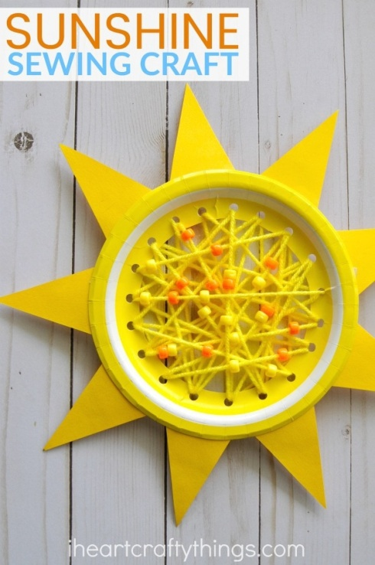
Supplies:
- Small yellow paper plate (We used 7-inch yellow dessert plates from Target. Find them on the party supply aisle.)
- yellow yarn
- Plastic yarn needle (optional, but I love them!)
- orange and yellow pony beads
- yellow construction paper
- scissors
- hole punch
- tape
- glue

Directions:
- Begin by drawing (or tracing) a circle on the back of your paper plate. Poke a hole into the circle with your scissors and then cut out the circle.
- Use a hole punch to punch holes around the entire perimeter of the circle about 1/2-inch to 1-inch apart.
- Cut off a long section of yarn and thread it through your plastic yarn needle. Tie a knot at the end of the yarn needle to secure it in place. Tape the end of the yarn onto the back of the paper plate.
- Kids can now begin sewing around the holes in the paper plate. Come up through a hole in the back of the paper plate to start, then go back down through a hole at the front of the paper plate. Continue this process, sewing through each of the holes in the paper plate.
- After you have sewn through all of the holes in the paper plate, start adding orange and yellow pony beads onto each of the stitches you make. This adds fun texture and color to your sewing craft. When you reach the end of your yarn, cut off the plastic yarn needle and tape the end of the yarn onto the back of the paper plate.
- Cut yellow triangles out of your construction paper for sun rays. Glue them onto the back of the paper plate along the outside rim of the plate.

